.NET JOURNAL PROGRAMS

Q1. Write a Vb.net program to check whether entered string is palindrome or not.

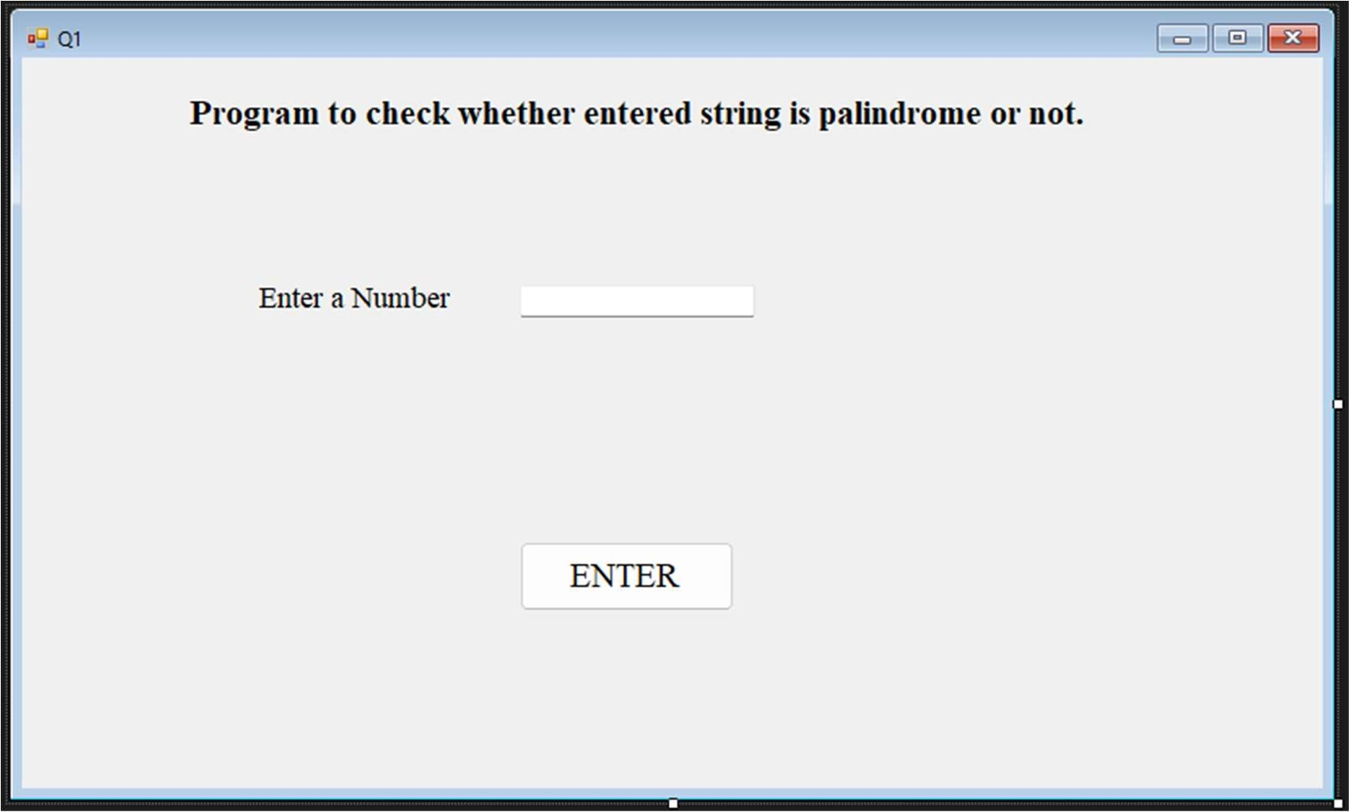

Public Class Q1

Private Sub Button1_Click(sender As Object, e As EventArgs) Handles Button1.Click Dim str1 As String

str1 = TextBox1.Text

If str1 = StrReverse(str1) Then MsgBox("String is palindrome")

Else

MsgBox("String is not palindrome") End If

End Sub End Class

OUTPUT: -

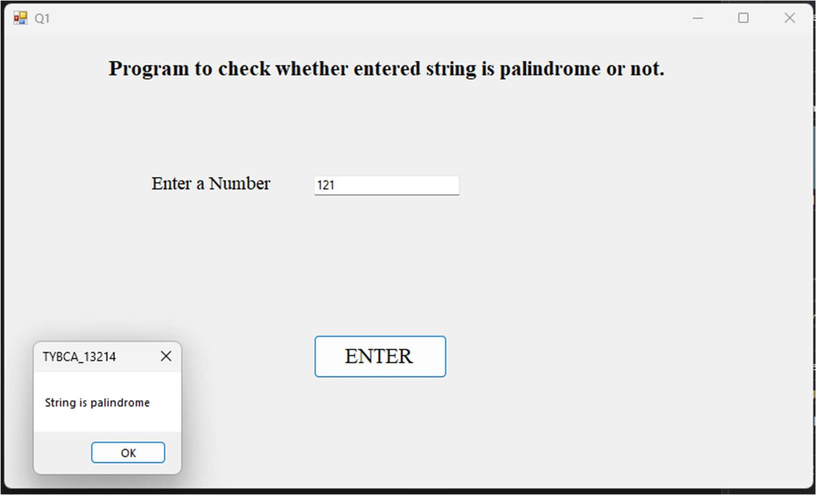

Q2. Write a Vb.net program for blinking an image.

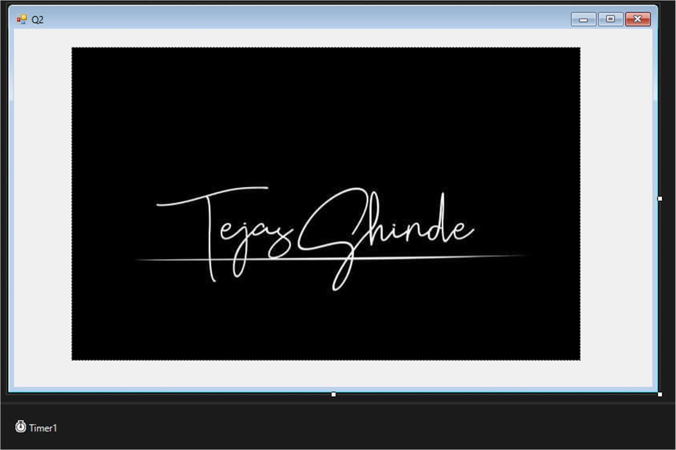

Public Class Q2

Private Sub Timer1_Tick(sender As Object, e As EventArgs) Handles Timer1.Tick

If PictureBox1.Visible = Visible Then PictureBox1.Visible = False

Else

PictureBox1.Visible = True End If

End Sub End Class

Q3. Write a Vb.Net program to move the Text “TC College” continuously from Left to Right.

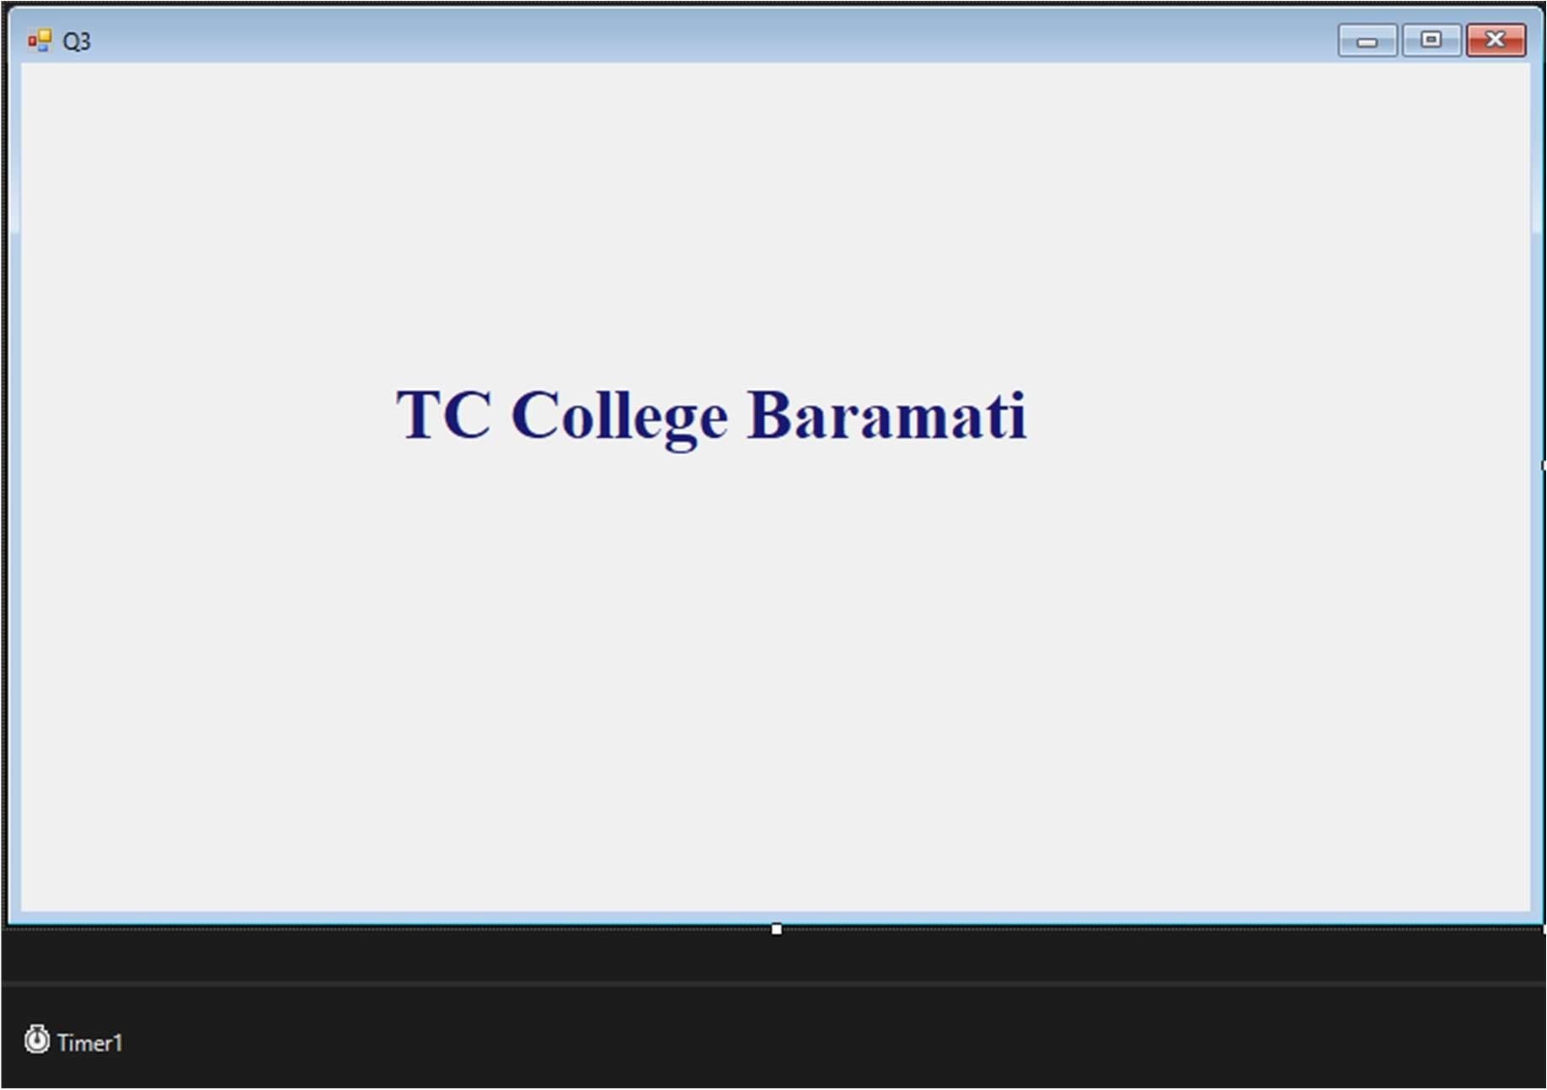

Public Class Q3

Private Sub Timer1_Tick(sender As Object, e As EventArgs) Handles Timer1.Tick Label1.Left = Label1.Left + 10

If Label1.Left >= Me.Right Then

Label1.Left = Me.Left End If

End Sub End Class

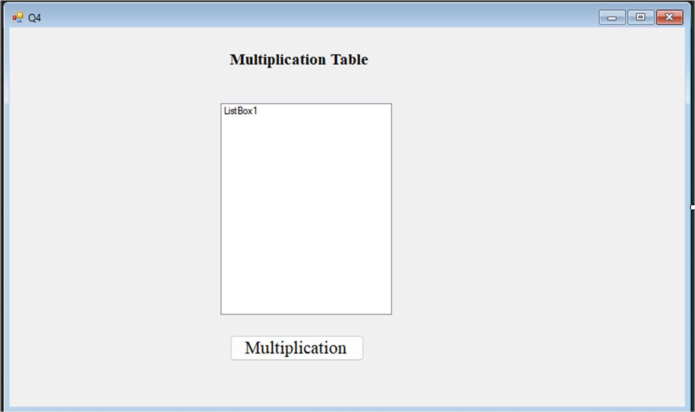Q4. Write a Vb.net program to accept a number from an user through InputBox and display its multiplication table into the ListBox.

Public Class Q4

Private Sub Button1_Click(sender As Object, e As EventArgs) Handles Button1.Click Dim n As Integer

ListBox1.Items.Clear()

n = CInt(InputBox("Enter number: ")) For i = 1 To 10

ListBox1.Items.Add(n * i) Next

End Sub End Class

OUTPUT: -

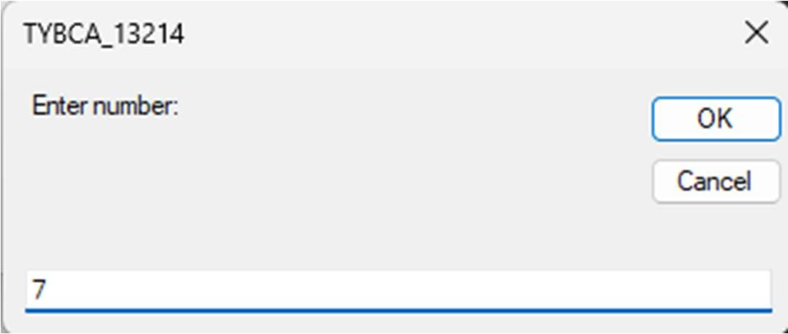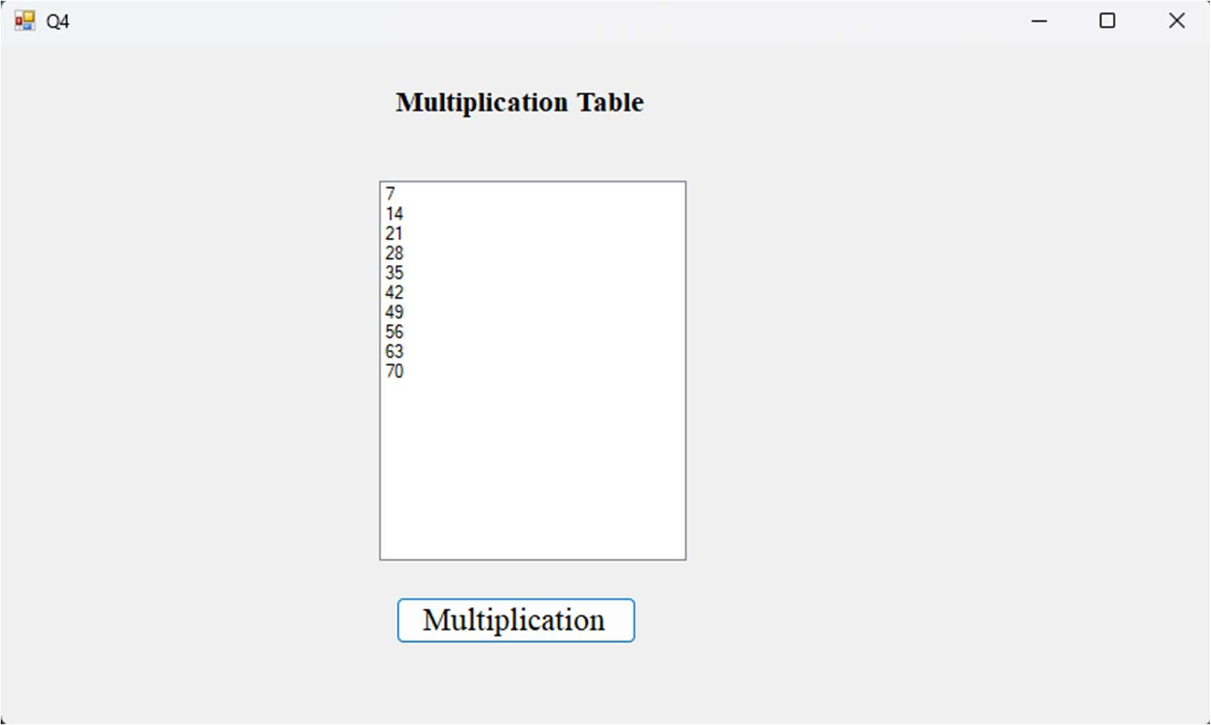

Q5. Write a Vb.net program to accept n numbers through InputBox and count the number of Armstrong and Perfect numbers among them and display their count by using messagebox

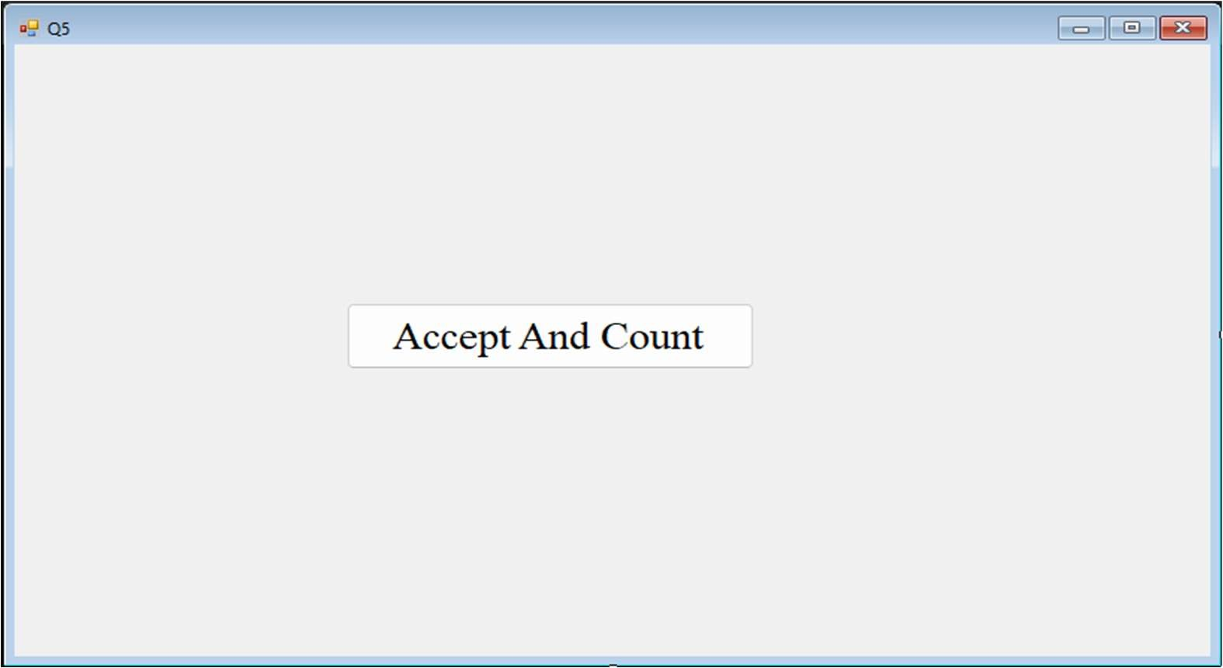

Public Class Q5

Private Sub Button1_Click(sender As Object, e As EventArgs) Handles Button1.Click Dim n As Integer

Dim a(10) As Integer Dim prime As Integer

Dim remainder, sum, copy As Integer Dim c, cn As Integer

n = InputBox("Enter how many number: ")

For i As Integer = 0 To n - 1

a(i) = InputBox("Enter Element:- ", i)

Next prime = 0

For i As Integer = 0 To n - 1

For j As Integer = 2 To a(i) / 2 If a(i) Mod j = 0 Then

prime = 1 Exit For

End If Next

If prime = 0 Then c = c + 1

End If copy = a(i) sum = 0

While a(i) > 0

remainder = a(i) Mod 10

sum = (remainder * remainder * remainder) + sum a(i) = a(i) \ 10

End While

If copy = sum Then cn = cn + 1

End If prime = 0

Next

MsgBox("Total number of perfect Number: " + CStr(c)) MsgBox("Total number of armstrong Number: " + CStr(cn))

End Sub End Class

Output: -

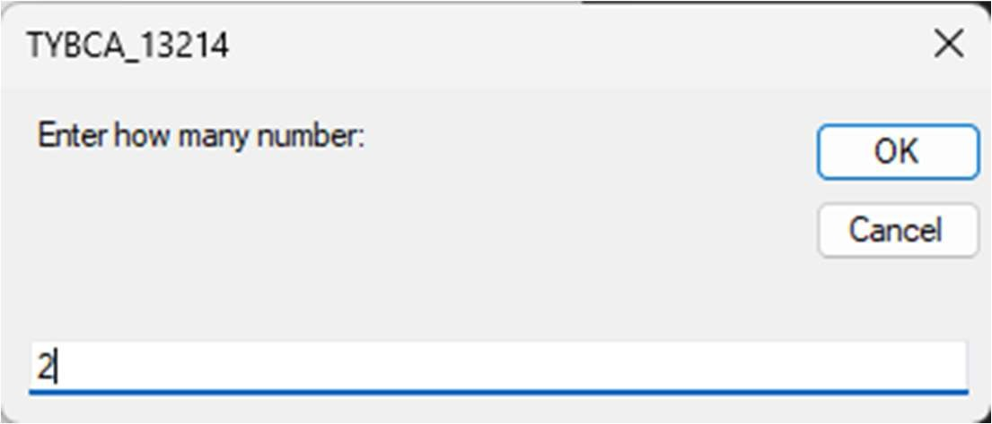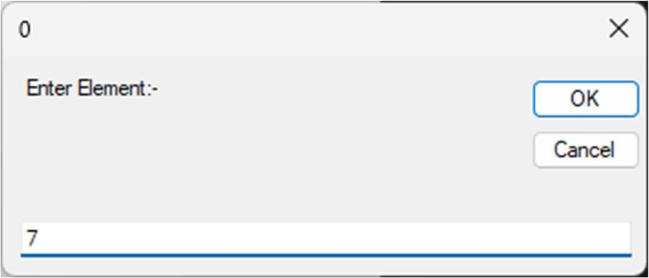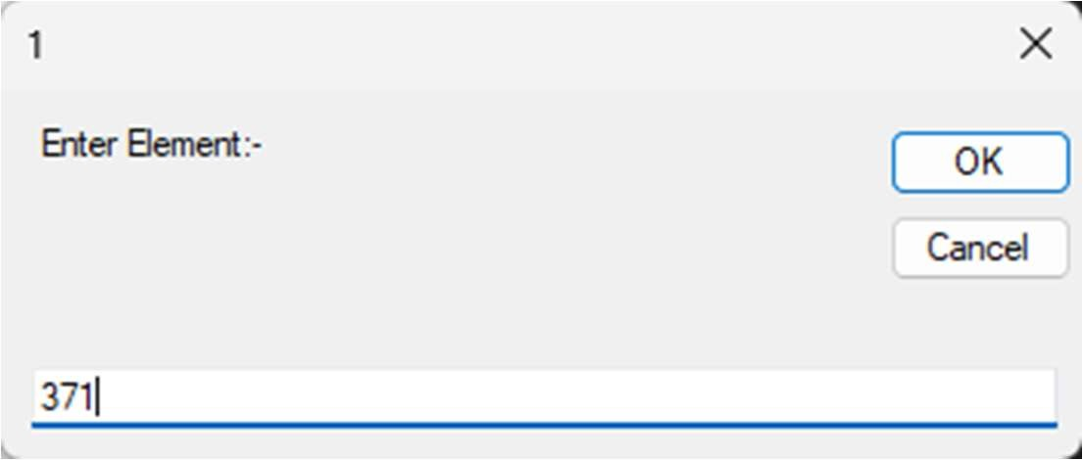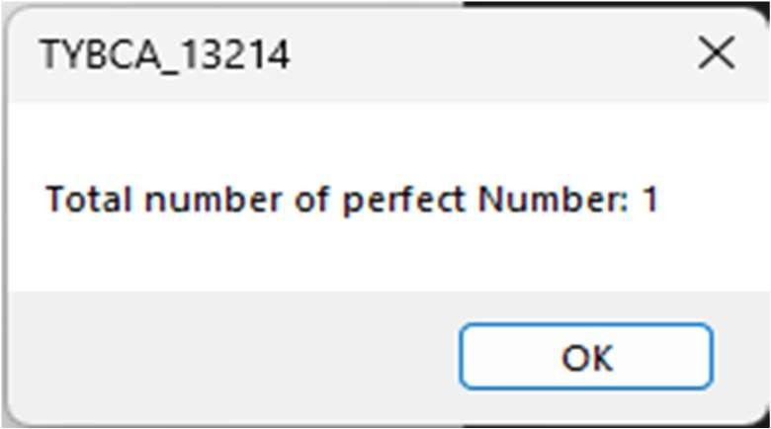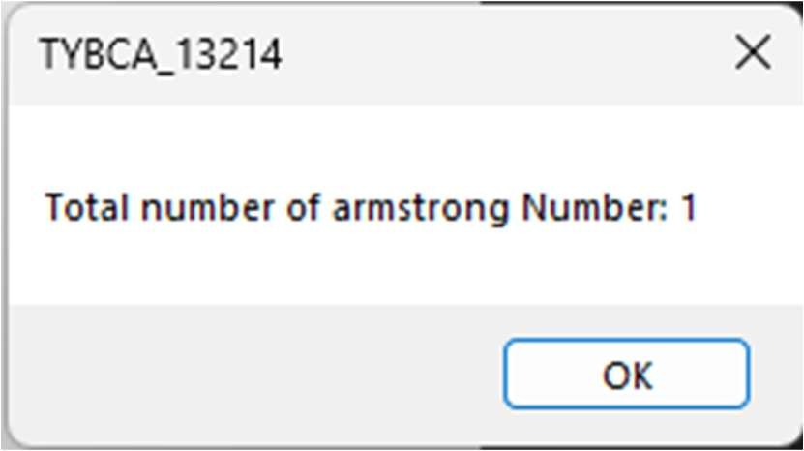

Q6. Write a Vb.net program to add two TextBoxes, two Labels and one button at runtime. Accept two numbers in textboxes and handle DivideByZeroException.

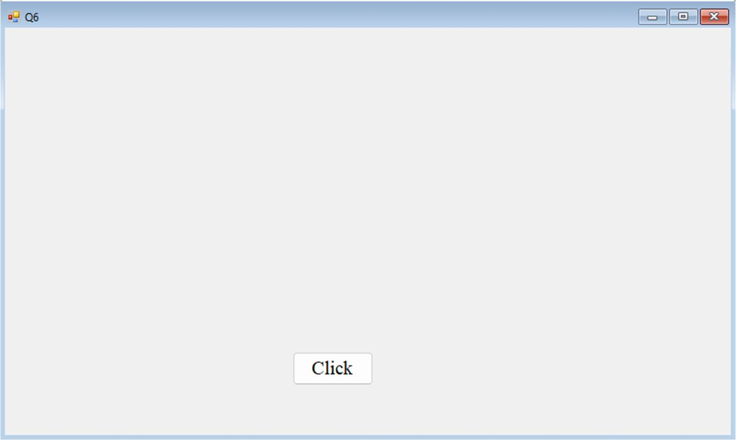

Public Class Q6

Dim t1 As New TextBox Dim t2 As New TextBox Dim l1 As New Label Dim l2 As New Label Dim b1 As New Button Dim n As Integer

Private Sub Q6_Load(sender As Object, e As EventArgs) Handles MyBase.Load l1.Top = 100

l1.Left = 100

l1.Text = "Enter 1st Number" l1.Visible = True Me.Controls.Add(l1)

l2.Text = "Enter 2nd Number" l2.Top = 100

l2.Left = 300 l2.Visible = True Me.Controls.Add(l2)

t1.Top = 125

t1.Left = 100 t1.Visible = True Me.Controls.Add(t1)

t2.Top = 125

t2.Left = 300 t2.Visible = True Me.Controls.Add(t2)

b1.Text = "Divide" b1.Top = 190

b1.Left = 220 b1.Visible = True Me.Controls.Add(b1)

AddHandler Button1.Click, AddressOf Button1_Click_1 End Sub

Private Sub Button1_Click_1(sender As Object, e As EventArgs)

Try

n = CInt(t1.Text) \ CInt(t2.Text) MsgBox(n)

Catch ex As DivideByZeroException

MsgBox(ex.Message)

End Try End Sub

Output: -

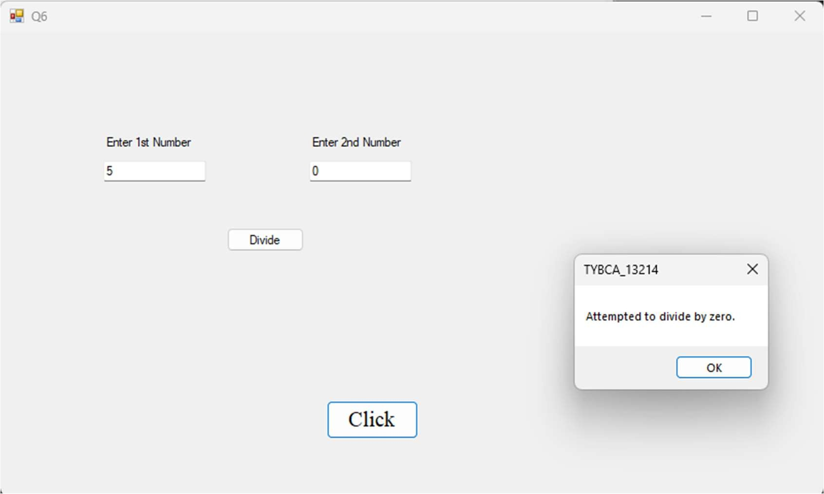

Q7. Write a Vb.net program to design following screen, accept the details from the user. Clicking on Submit button Net Salary should be calculated and displayed into the TextBox. Display the MessageBox informing the Name and Net Salary of employee.

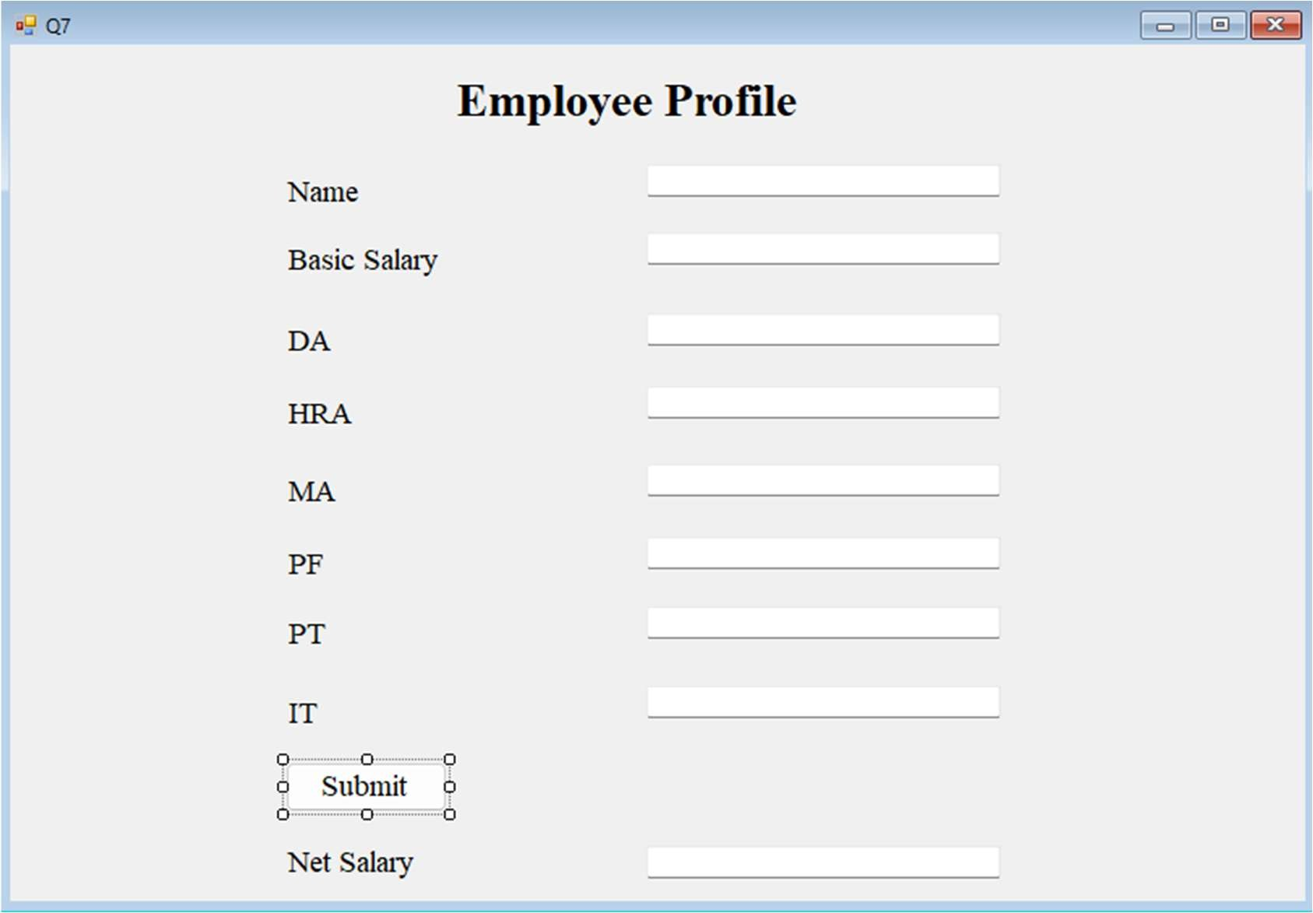

Public Class Q7

Private Sub Button1_Click(sender As Object, e As EventArgs) Handles Button1.Click Dim cal, tax, bs, da, hra, ma, pf, pt, it As Integer

bs = CInt(TextBox2.Text) da = CInt(TextBox3.Text) hra = CInt(TextBox4.Text) ma = CInt(TextBox5.Text) pf = CInt(TextBox6.Text) pt = CInt(TextBox7.Text) it = CInt(TextBox8.Text)

cal = bs + ((da * bs) / 100) + ((hra * bs) / 100) + ((ma * bs) / 100) tax = ((pt * bs) / 100) + ((it * bs) / 100) + ((pf * bs) / 100)

cal = cal - tax

TextBox9.Text = cal

MsgBox("Name: " + TextBox1.Text + " Net salary: " + TextBox9.Text)

End Sub End Class

Output: -

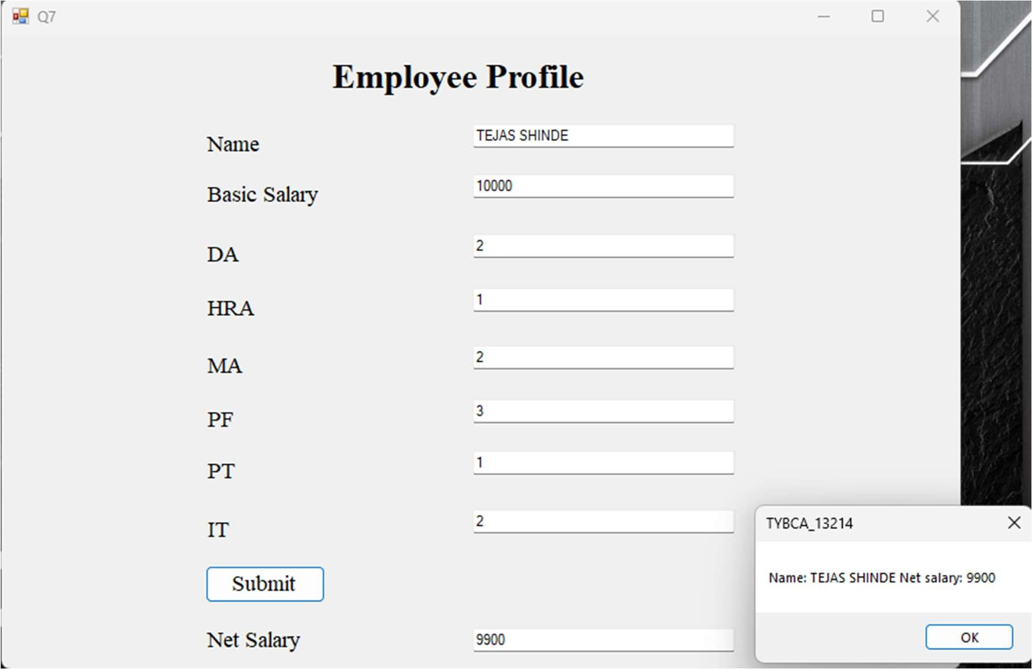

Q8. Write a Vb.net program to accept number from user into the TextBox. Calculate the square root of that number also convert the entered number into binary number and display result into the Message Box

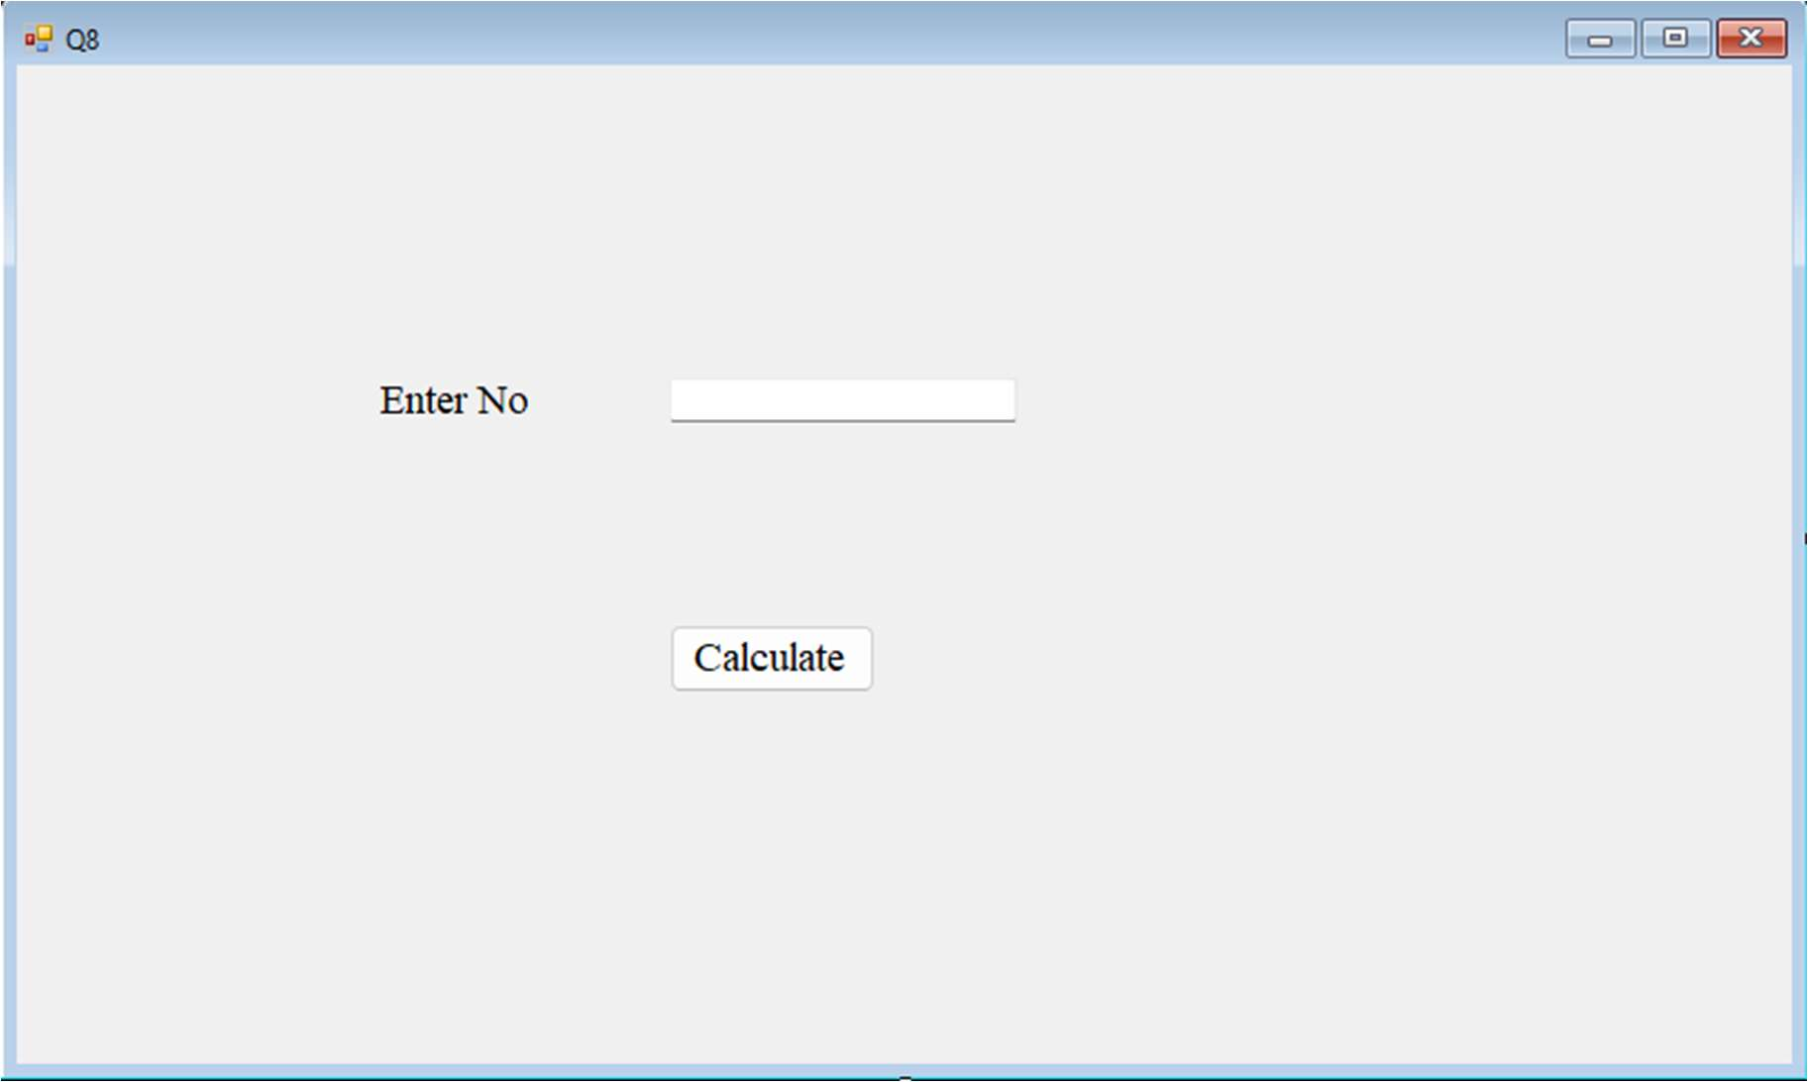

Public Class Q8

Private Sub Button1_Click(sender As Object, e As EventArgs) Handles Button1.Click Dim n As Integer

Dim sqr As Double Dim rm As Integer Dim str1 As String

n = CInt(TextBox1.Text) sqr = Math.Sqrt(n)

While n

rm = n Mod 2 str1 = str1 & rm n = n / 2

End While

MessageBox.Show("Square Root:" & sqr & "Binary Number:" & str1) StrReverse(str1)

End Sub End Class

Output: -

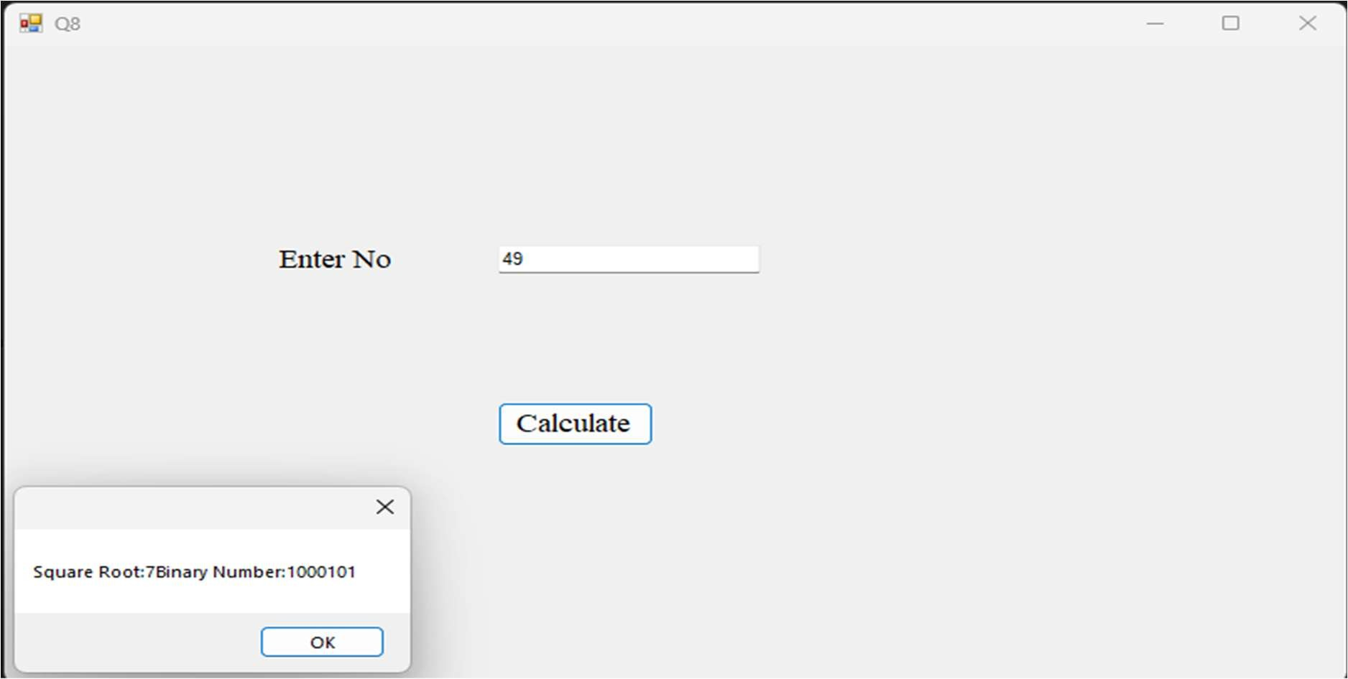

Q9. Design a Vb.net form to pick a date from DateTimePicker Control and display day, month and year in separate text boxes.

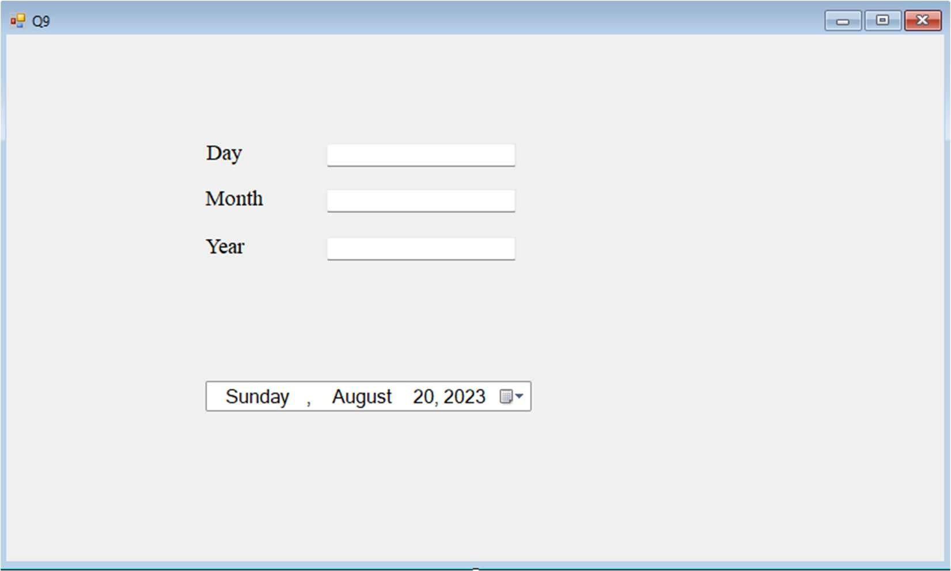

Public Class Q9

Private Sub DateTimePicker1_ValueChanged(sender As Object, e As EventArgs) Handles DateTimePicker1.ValueChanged

TextBox1.Text = DateTimePicker1.Value.Day TextBox2.Text = DateTimePicker1.Value.Month TextBox3.Text = DateTimePicker1.Value.Year

End Sub End Class

Output: -

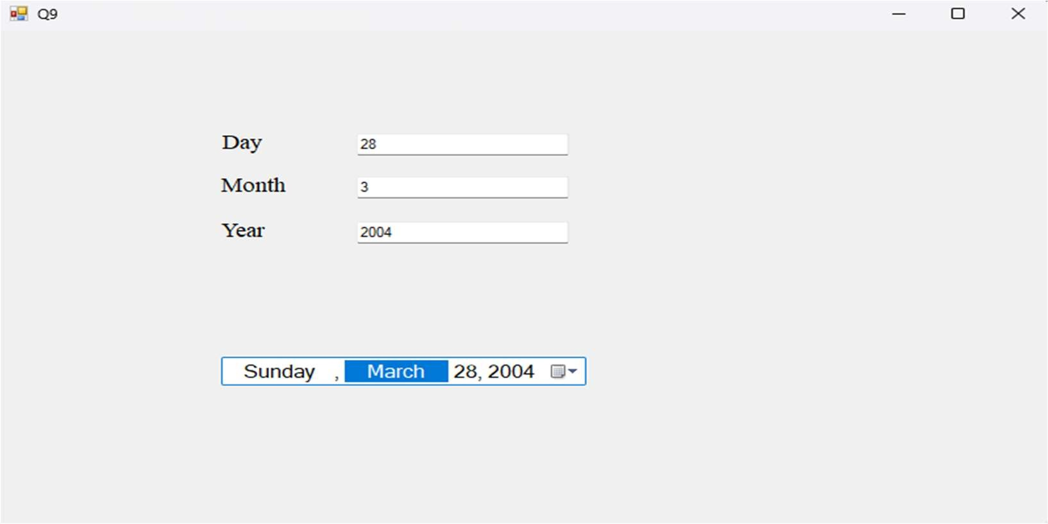

Q10. Write a Vb.net program to accept a character from keyboard and check whether it is vowel or not. Also display the case of that character.

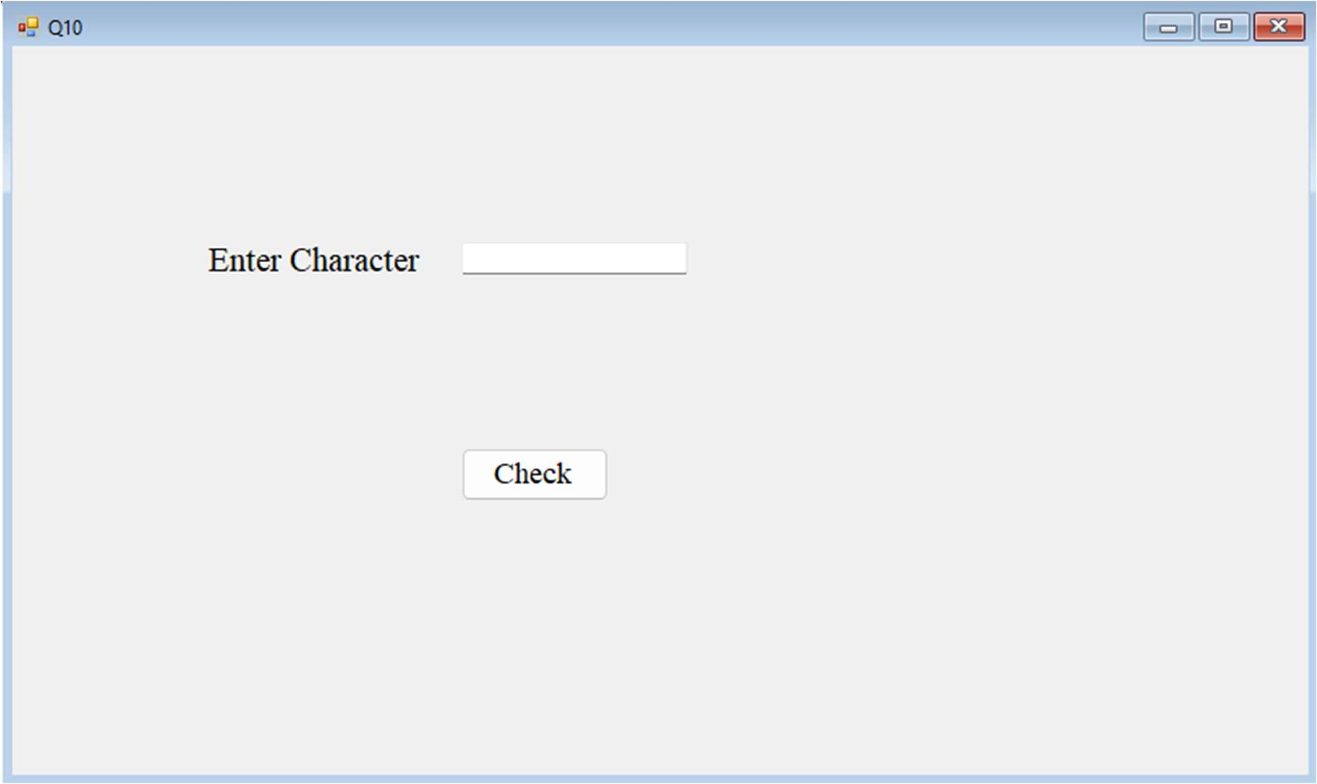

Public Class Q10

Private Sub Button1_Click(sender As Object, e As EventArgs) Handles Button1.Click Dim ch As Char

ch = TextBox1.Text Select Case ch

Case "A", "E", "I", "O", "U"

MessageBox.Show(ch + " is Vowel And UpperCase") Case "a", "e", "i", "o", "u"

MessageBox.Show(ch + " is Vowel And LowerCase") Case Else

MessageBox.Show(ch + " is Not Vowel") End Select

End Sub End Class

Output: -

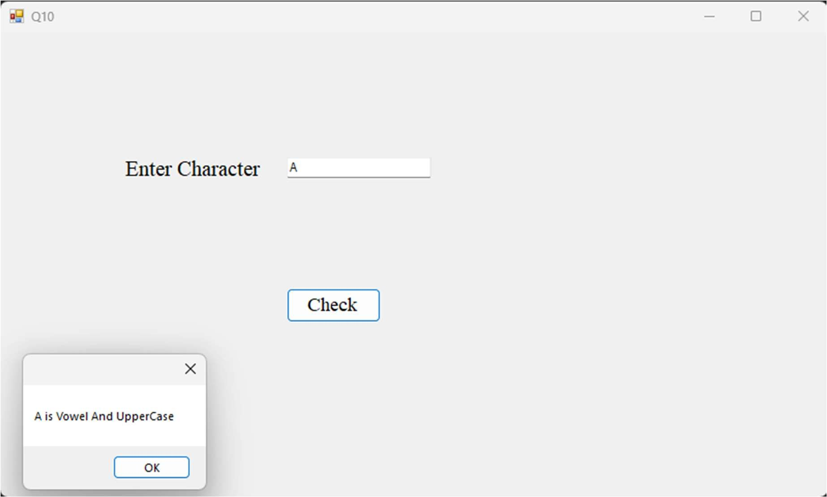

Q11. Write a Vb.net program to accept sentences in text box and count the number of words and display the count in message box.

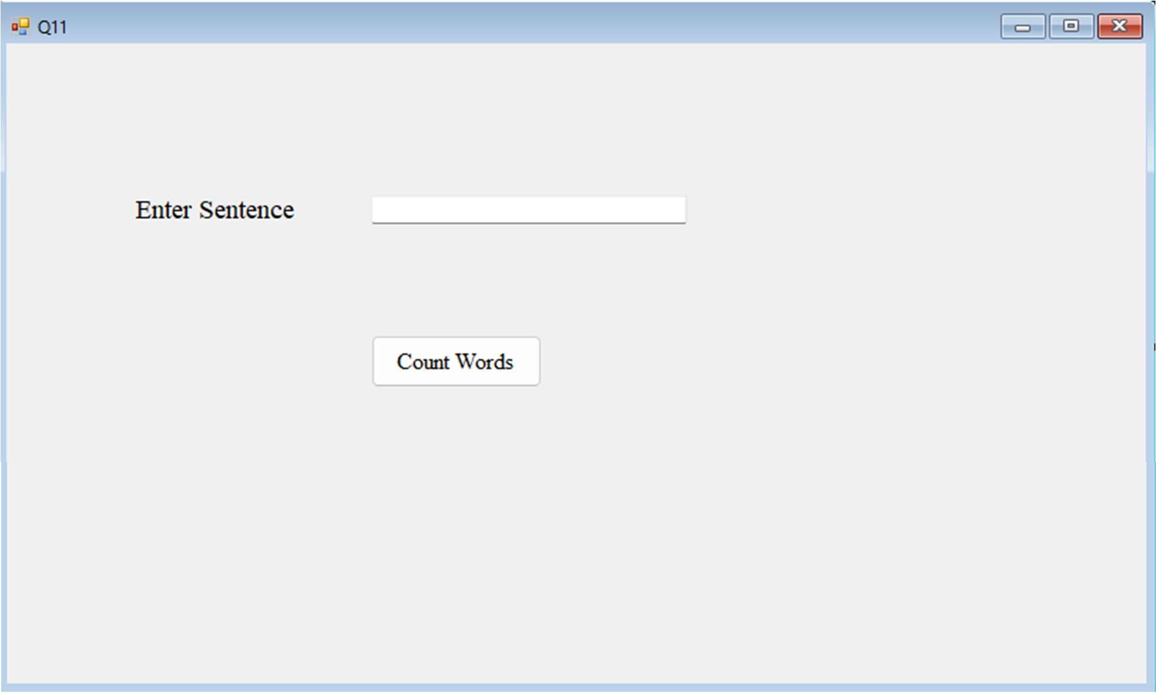

Public Class Q11

Private Sub Button1_Click(sender As Object, e As EventArgs) Handles Button1.Click

Dim sentence As String Dim i As Integer

Dim wc As Integer sentence = TextBox1.Text

Dim arr() As Char = sentence.ToCharArray For i = 0 To arr.Length - 1

If arr(i) = " " Then wc = wc + 1

End If Next

MsgBox("Total Words: " & wc + 1) End Sub

End Class

Output: -

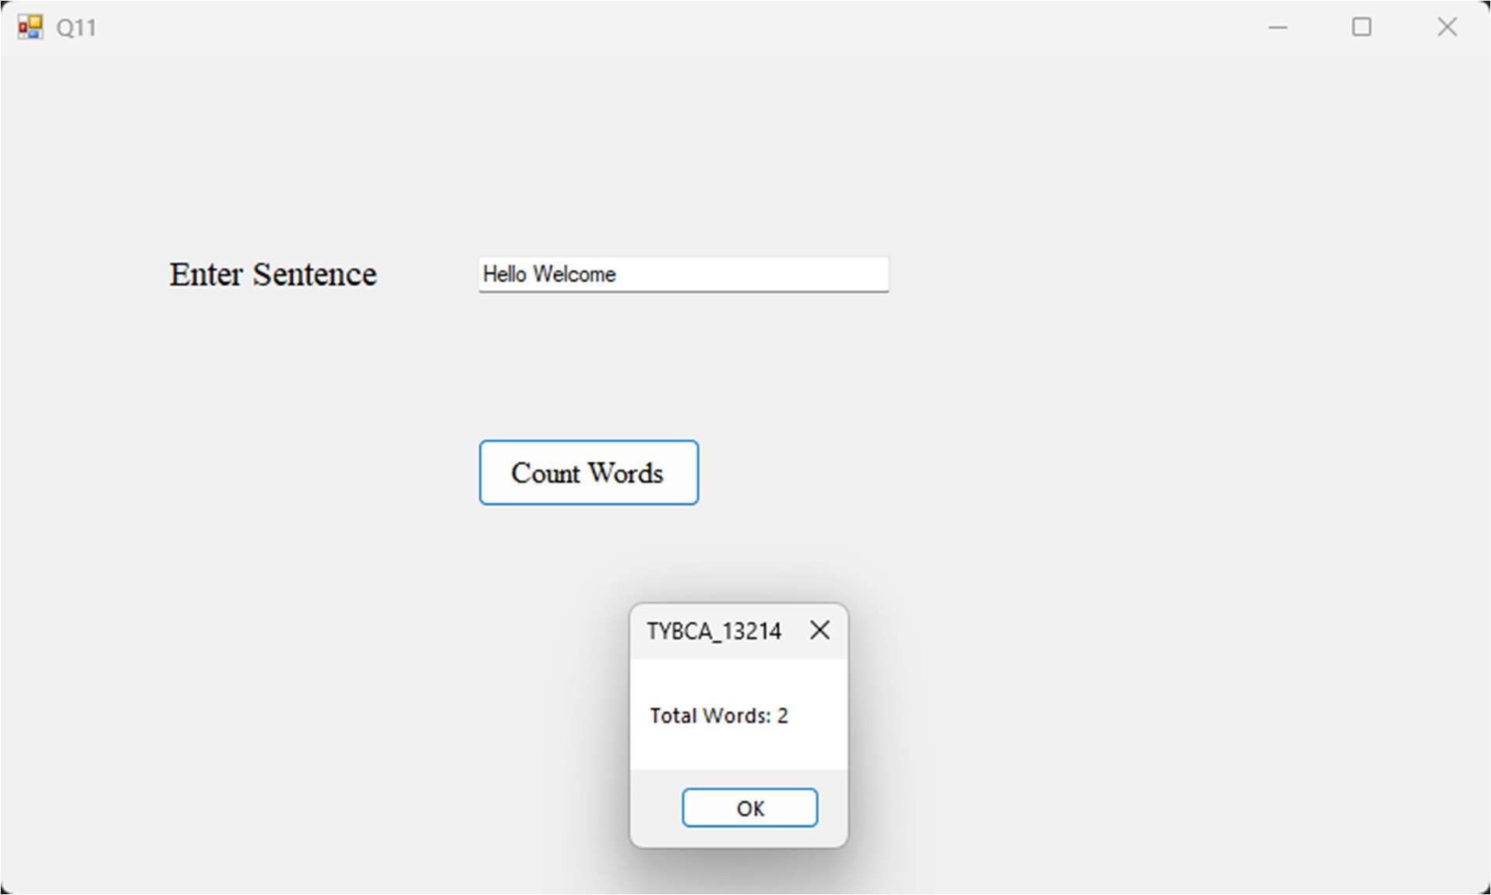

Q12. Write a Vb.net program to design the following form, accept the numbers through textbox and add them into the ListBoxe1 by clicking on Add button. When user click on Prime button then all the prime numbers from ListBox1 should get added into ListBox2.

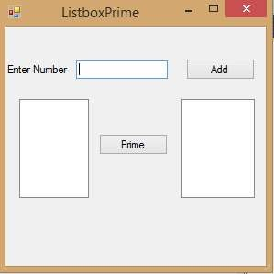

Public Class Q12

Private Sub Button1_Click(sender As Object, e As EventArgs) Handles Button1.Click ListBox1.Items.Add(CInt(TextBox1.Text))

TextBox1.Text = "" TextBox1.Focus()

End Sub

Private Sub Button2_Click(sender As Object, e As EventArgs) Handles Button2.Click Dim n, i, mm, count, contain As Integer

For i = 0 To ListBox1.Items.Count() - 1 n = ListBox1.Items.Item(i)

count = CInt(n) / 2 mm = 1

For j As Integer = 2 To count If n Mod j = 0 Then

mm = 0

End If Next

If mm = 1 Then ListBox2.Items.Add(CInt(n))

End If Next

contain = ListBox1.Items.Count() - 1 ' 4 i = 0

While True

If contain >= i Then

n = ListBox1.Items.Item(i) count = CInt(n) / 2

mm = 1

For j As Integer = 2 To count If n Mod j = 0 Then

mm = 0 End If

Next

If mm = 1 Then ListBox1.Items.RemoveAt(i)

Else

i = i + 1 End If

contain = ListBox1.Items.Count() - 1 Else

Exit While

End If End While

End Sub End Class

Output: -

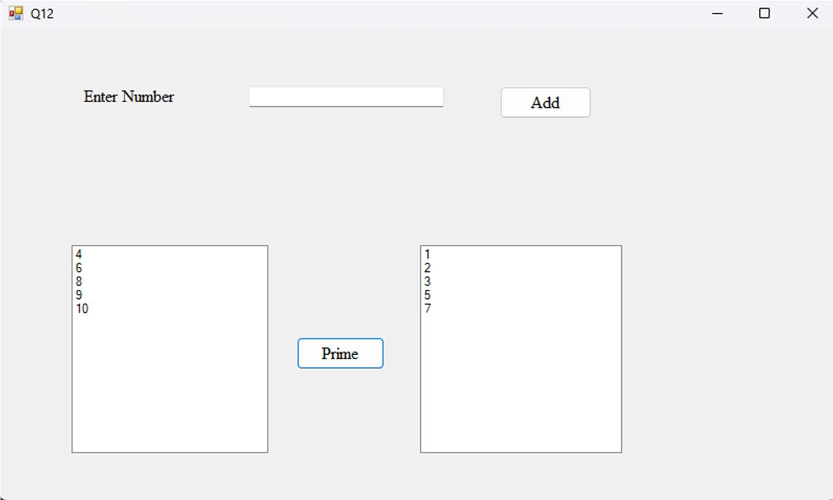

Q13. Write a Vb.net program to design the following form, allow the user to select radio buttons from Gender and Age Panel. After Selection appropriate CheckBox from Right Panel should be selected automatically. Display appropriate message into the MessageBox by clicking on Ok button.

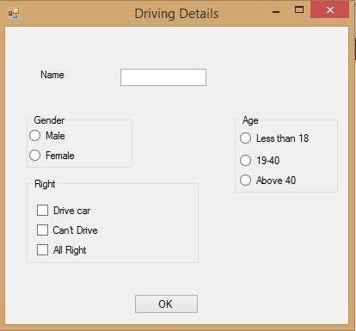

Public Class Q13

Private Sub Button1_Click(sender As Object, e As EventArgs) Handles Button1.Click If TextBox1.Text = "" Then

MessageBox.Show("Please Enter Name") Else

Dim age As String age = ""

If RadioButton3.Checked Then

age = "Less Than 18. Can't Drive "

ElseIf RadioButton4.Checked Then

age = "Between 18 To 40 . Can Drive"

ElseIf RadioButton5.Checked Then age = "Above 40. All Right "

End If

MessageBox.Show("Name : " + TextBox1.Text + " Age : " + age)

End If End Sub

Private Sub RadioButton3_CheckedChanged(sender As Object, e As EventArgs) Handles RadioButton3.CheckedChanged

If RadioButton3.Checked Then CheckBox2.Checked = True

Else

CheckBox2.Checked = False End If

End Sub

Private Sub RadioButton4_CheckedChanged(sender As Object, e As EventArgs) Handles RadioButton4.CheckedChanged

If RadioButton4.Checked Then CheckBox1.Checked = True

Else

CheckBox1.Checked = False End If

End Sub

Private Sub RadioButton5_CheckedChanged(sender As Object, e As EventArgs) Handles RadioButton5.CheckedChanged

If RadioButton5.Checked Then CheckBox3.Checked = True

Else

CheckBox3.Checked = False End If

End Sub End Class

Output: -

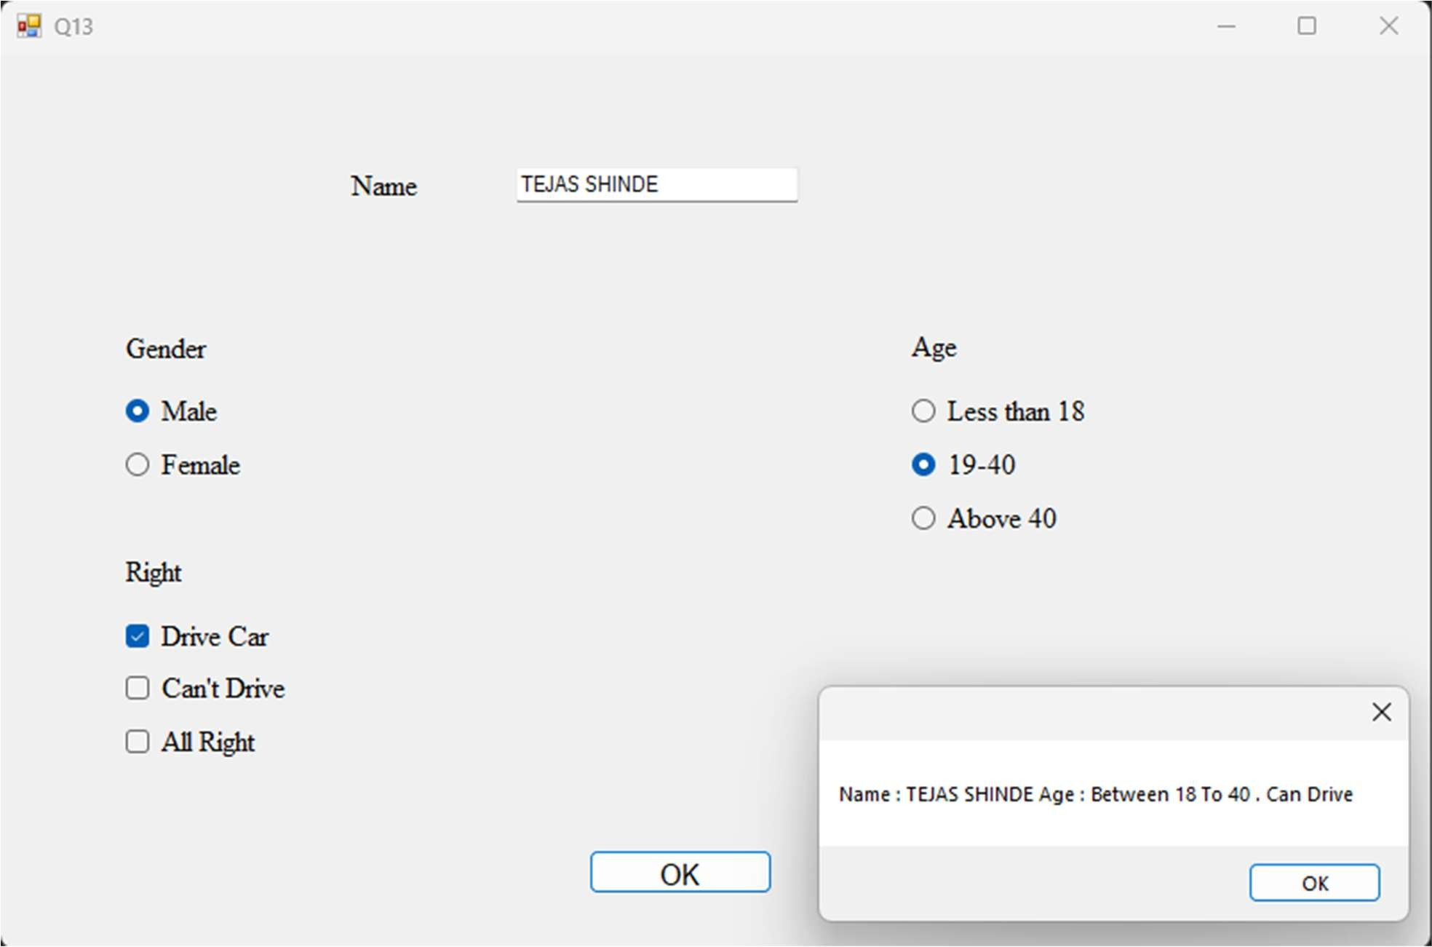

Q14. Write a Vb.net program to design the following form, select the question number from combo box that question will be displayed into textbox and the options for that question will be displayed on four radio buttons, select option and click on submit button result should be displayed in another textbox.

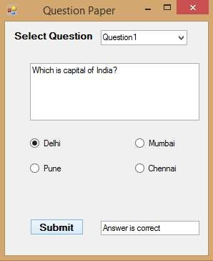

Public Class Q14

Private Sub ComboBox1_SelectedIndexChanged(sender As Object, e As EventArgs) Handles ComboBox1.SelectedIndexChanged

If ComboBox1.SelectedItem() = "Question 1" Then RichTextBox1.Text = "What is Capital Of India ?" RadioButton1.Text = "Delhi"

RadioButton2.Text = "Pune" RadioButton3.Text = "Mumbai" RadioButton4.Text = "Chennai"

End If

If ComboBox1.SelectedItem() = "Question 2" Then RichTextBox1.Text = "What is Capital Of Maharashtra ?" RadioButton1.Text = "Pune"

RadioButton2.Text = "Nagpur" RadioButton3.Text = "Mumbai" RadioButton4.Text = "Nagar"

End If

End Sub

Private Sub Button1_Click(sender As Object, e As EventArgs) Handles Button1.Click Dim correct As String

Dim wrong As String

correct = "Answer is correct" wrong = "Answer is wrong"

If ComboBox1.SelectedItem() = "Question 1" Then If RadioButton1.Checked Then

TextBox1.Text = correct

ElseIf RadioButton2.Checked Then TextBox1.Text = wrong

ElseIf RadioButton3.Checked Then TextBox1.Text = wrong

ElseIf RadioButton4.Checked Then TextBox1.Text = wrong

End If End If

If ComboBox1.SelectedItem() = "Question 2" Then If RadioButton1.Checked Then

TextBox1.Text = wrong

ElseIf RadioButton2.Checked Then TextBox1.Text = wrong

ElseIf RadioButton3.Checked Then TextBox1.Text = correct

ElseIf RadioButton4.Checked Then TextBox1.Text = wrong

End If End If

End Sub End Class

Output: -

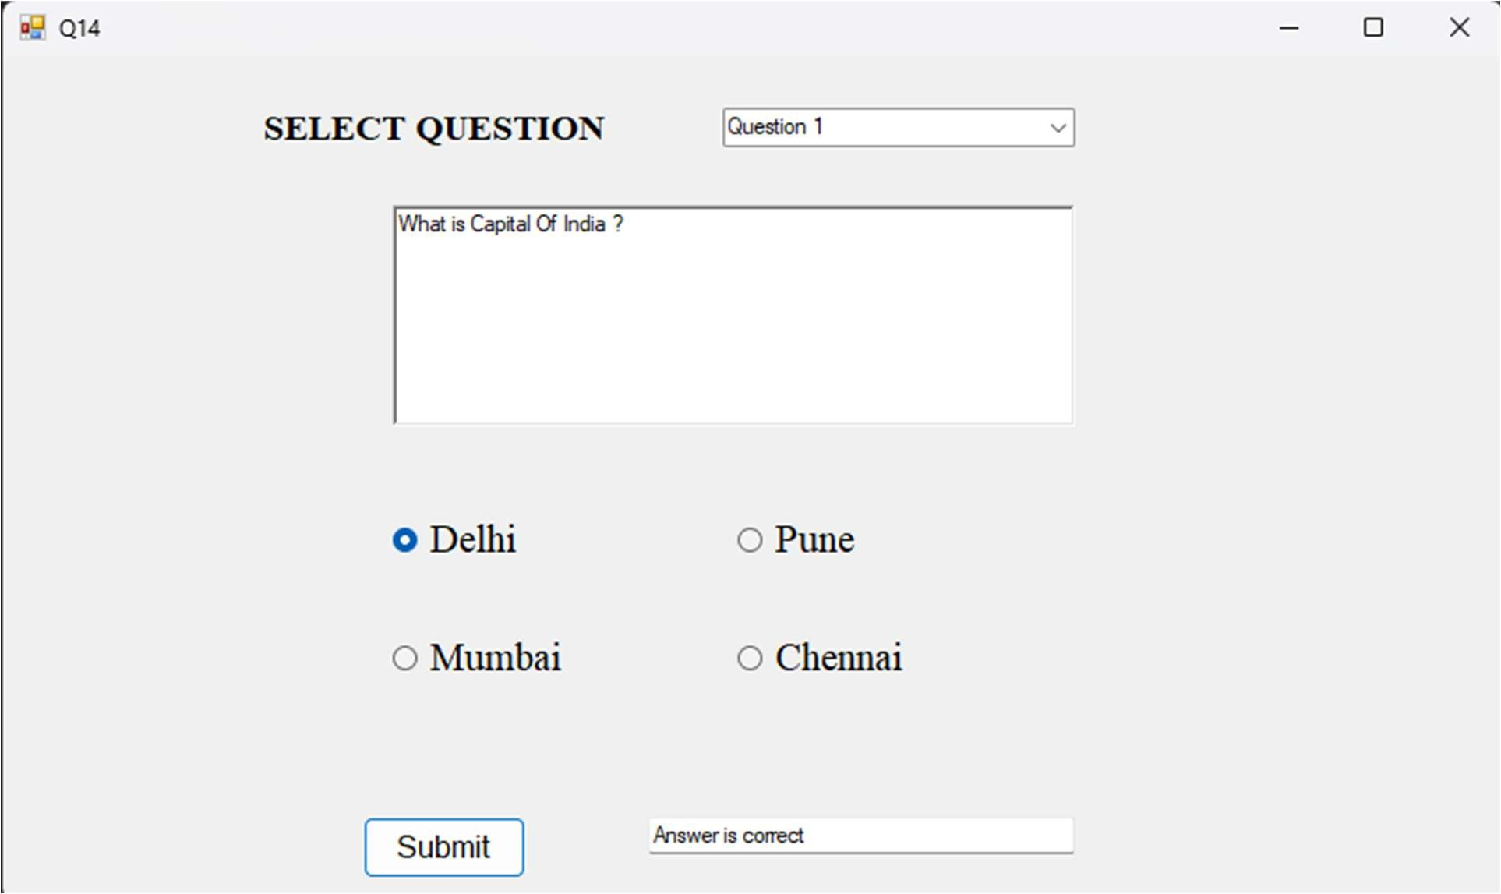

Q15. Write a Vb.net program to generate Sample TreeView control shown in following form:

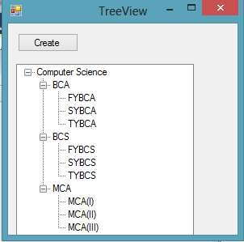

Public Class Q15

Private Sub Button1_Click(sender As Object, e As EventArgs) Handles Button1.Click TreeView2.Nodes.Add("Computer Science") TreeView2.Nodes(0).Nodes.Add("BCA") TreeView2.Nodes(0).Nodes(0).Nodes.Add("FYBCA") TreeView2.Nodes(0).Nodes(0).Nodes.Add("SYBCA") TreeView2.Nodes(0).Nodes(0).Nodes.Add("TYBCA")

TreeView2.Nodes(0).Nodes.Add("BSC") TreeView2.Nodes(0).Nodes(1).Nodes.Add("FYBSC") TreeView2.Nodes(0).Nodes(1).Nodes.Add("SYBSC") TreeView2.Nodes(0).Nodes(1).Nodes.Add("TYBSC")

TreeView2.Nodes(0).Nodes.Add("MCA") TreeView2.Nodes(0).Nodes(2).Nodes.Add("MCA(I)") TreeView2.Nodes(0).Nodes(2).Nodes.Add("MCA(II)") TreeView2.Nodes(0).Nodes(2).Nodes.Add("MCA(III)")

End Sub End Class

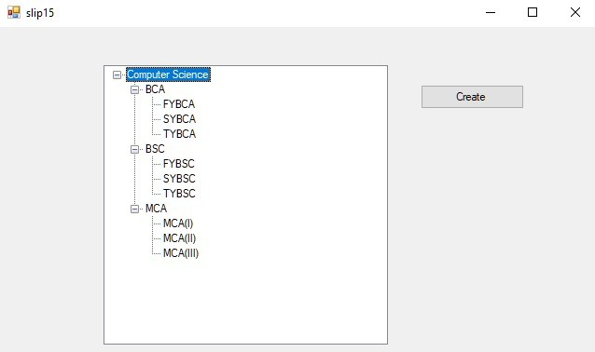

Q16. Write a Vb.net program to design the following form, it contains the three menus Color (Red,Blue,Green) ,Window(Maximize, Minimize, Restore) and Exit. On Selection of any menu or submenu result should affect the form control( for example if user selected Red color from Color menu back color of form should get changed to Red and if user selected Maximize from Window Menu then form should get maximized).

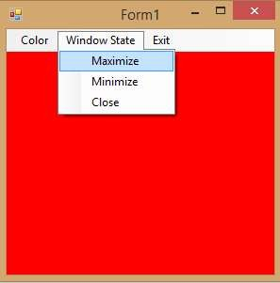

Public Class Q16

Private Sub RedToolStripMenuItem_Click(sender As Object, e As EventArgs) Handles RedToolStripMenuItem.Click

Me.BackColor = Color.Red End Sub

Private Sub BlueToolStripMenuItem_Click(sender As Object, e As EventArgs) Handles BlueToolStripMenuItem.Click

Me.BackColor = Color.Blue End Sub

Private Sub GreenToolStripMenuItem_Click(sender As Object, e As EventArgs) Handles GreenToolStripMenuItem.Click

Me.BackColor = Color.Green

End Sub

Private Sub MaximizeToolStripMenuItem_Click(sender As Object, e As EventArgs) Handles MaximizeToolStripMenuItem.Click

Me.WindowState = FormWindowState.Maximized End Sub

Private Sub MinimizeToolStripMenuItem_Click(sender As Object, e As EventArgs) Handles MinimizeToolStripMenuItem.Click

Me.WindowState = FormWindowState.Minimized End Sub

Private Sub RestoreToolStripMenuItem_Click(sender As Object, e As EventArgs) Handles RestoreToolStripMenuItem.Click

Me.WindowState = FormWindowState.Normal End Sub

Private Sub ExitToolStripMenuItem_Click(sender As Object, e As EventArgs) Handles ExitToolStripMenuItem.Click

Me.Close() End Sub

End Class

Q17. Write a Vb.net program to design the following form, this program shows the details of students in the form of form (use split container or Groupbox control to separate the input and output session). [Marks 20]

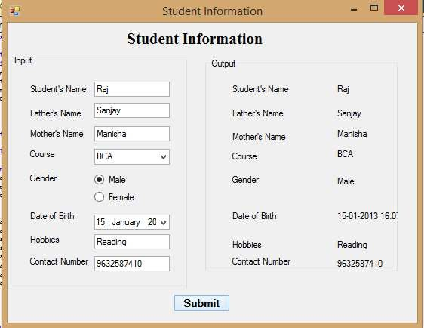

Public Class Q17

Private Sub Q17_Load(sender As Object, e As EventArgs) Handles MyBase.Load Panel2.Hide()

End Sub

Private Sub Button1_Click(sender As Object, e As EventArgs) Handles Button1.Click Panel2.Show()

Label12.Text = TextBox1.Text Label13.Text = TextBox2.Text Label14.Text = TextBox3.Text Label15.Text = ComboBox1.SelectedItem()

If RadioButton1.Checked = True Then Label16.Text = RadioButton1.Text

ElseIf RadioButton2.Checked = True Then

Label16.Text = RadioButton2.Text End If

Label17.Text = DateTimePicker1.Value Label18.Text = TextBox4.Text Label19.Text = TextBox5.Text

End Sub End Class

Q18. Write a Vb.net program to design the following form, accept all details from user and display the details through message box.

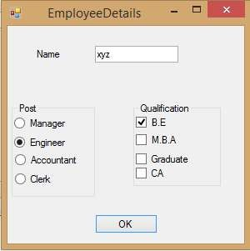

Public Class Form1

Private Sub Button1_Click(sender As Object, e As EventArgs) Handles Button1.Click Dim a, b, c As String

c = TextBox1.Text

If CheckBox1.Checked = True And CheckBox2.Checked = True Then a = CheckBox1.Text

a = CheckBox2.Text

ElseIf CheckBox2.Checked = True Then a = CheckBox2.Text

ElseIf CheckBox3.Checked = True Then a = CheckBox3.Text

ElseIf CheckBox4.Checked = True Then a = CheckBox4.Text

End If

If RadioButton1.Checked = True Then b = RadioButton1.Text

ElseIf RadioButton2.Checked = True Then b = RadioButton2.Text

ElseIf RadioButton3.Checked = True Then

b = RadioButton3.Text

ElseIf RadioButton4.Checked = True Then b = RadioButton4.Text

End If

MessageBox.Show("Name: " + c + " Post: " + b + " Qualification: " + a) End Sub

End Class

Q19. Develop the menu based Vb.net application to implement a text editor with cut, copy, paste, save, close operations.

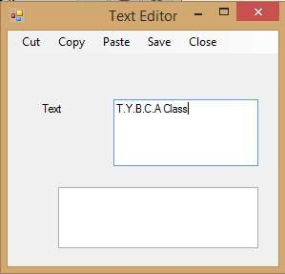

Public Class Q19

Private Sub SaveToolStripMenuItem_Click(sender As Object, e As EventArgs) Handles SaveToolStripMenuItem.Click

Dim path As String

If DialogResult.OK = SaveFileDialog1.ShowDialog() Then path = SaveFileDialog1.FileName

RichTextBox1.SaveFile(path, RichTextBoxStreamType.PlainText) MsgBox("File saved successfully")

End If End Sub

Private Sub CutToolStripMenuItem_Click(sender As Object, e As EventArgs) Handles CutToolStripMenuItem.Click

RichTextBox1.Cut() End Sub

Private Sub CopyToolStripMenuItem_Click(sender As Object, e As EventArgs) Handles CopyToolStripMenuItem.Click

RichTextBox1.Copy()

End Sub

Private Sub PasteToolStripMenuItem_Click(sender As Object, e As EventArgs) Handles PasteToolStripMenuItem.Click

RichTextBox2.Paste() End Sub

Private Sub CloseToolStripMenuItem_Click(sender As Object, e As EventArgs) Handles CloseToolStripMenuItem.Click

Me.Close() End Sub

End Class

Q20. Write a VB.NET program to do the following operations on RichTextBox values

1. Font Style
2. Font Color
3. Save
4. Open

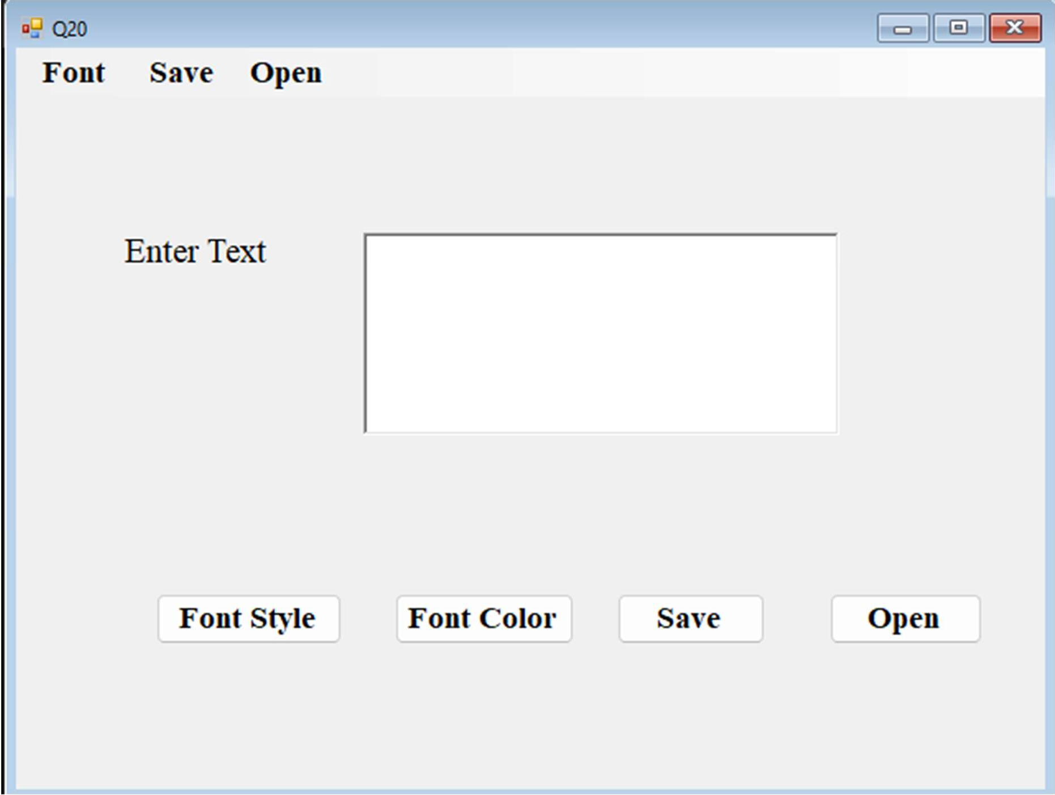

Public Class Q20

Private Sub Button1_Click(sender As Object, e As EventArgs) Handles Button1.Click FontDialog1.ShowDialog()

RichTextBox1.Font = FontDialog1.Font End Sub

Private Sub Button2_Click(sender As Object, e As EventArgs) Handles Button2.Click ColorDialog1.ShowDialog()

RichTextBox1.ForeColor = ColorDialog1.Color End Sub

Private Sub Button3_Click(sender As Object, e As EventArgs) Handles Button3.Click Dim path As String

If DialogResult.OK = SaveFileDialog1.ShowDialog() Then path = SaveFileDialog1.FileName

RichTextBox1.SaveFile(path, RichTextBoxStreamType.PlainText) MsgBox("File saved successfully")

End If

End Sub

Private Sub Button4_Click(sender As Object, e As EventArgs) Handles Button4.Click Dim path As String

If DialogResult.OK = OpenFileDialog1.ShowDialog() Then path = OpenFileDialog1.FileName

RichTextBox1.LoadFile(path, RichTextBoxStreamType.PlainText) MsgBox("File Open successfully ")

End If End Sub

Private Sub FontStyleToolStripMenuItem_Click(sender As Object, e As EventArgs) Handles FontStyleToolStripMenuItem.Click

End Sub

Private Sub StyleToolStripMenuItem_Click(sender As Object, e As EventArgs) Handles StyleToolStripMenuItem.Click

FontDialog1.ShowDialog() RichTextBox1.Font = FontDialog1.Font

End Sub

Private Sub ColorToolStripMenuItem_Click(sender As Object, e As EventArgs) Handles ColorToolStripMenuItem.Click

ColorDialog1.ShowDialog() RichTextBox1.ForeColor = ColorDialog1.Color

End Sub

Private Sub SaveToolStripMenuItem_Click(sender As Object, e As EventArgs) Handles SaveToolStripMenuItem.Click

Dim path As String

If DialogResult.OK = SaveFileDialog1.ShowDialog() Then path = SaveFileDialog1.FileName

RichTextBox1.SaveFile(path, RichTextBoxStreamType.PlainText) MsgBox("File saved successfully")

End If End Sub

Private Sub OpToolStripMenuItem_Click(sender As Object, e As EventArgs) Handles OpToolStripMenuItem.Click

Dim path As String

If DialogResult.OK = OpenFileDialog1.ShowDialog() Then path = OpenFileDialog1.FileName

RichTextBox1.LoadFile(path, RichTextBoxStreamType.PlainText) MsgBox("File Open successfully ")

End If End Sub

End Class

Q21. Create a project to design a calculator using control array

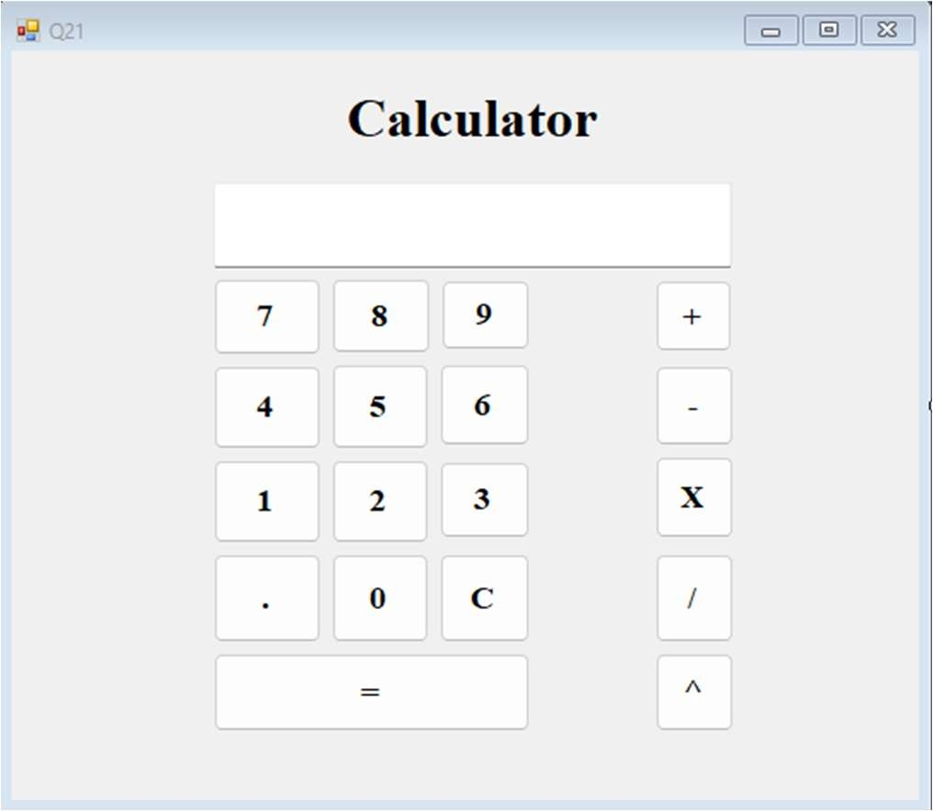

Public Class Q21 Dim a As Double Dim b As Double Dim c As Double Dim op As Char

Private Sub Button1_Click(sender As Object, e As EventArgs) Handles Button1.Click If TextBox1.Text = "0" Then

TextBox1.Text = "7" Else

TextBox1.Text += "7" End If

End Sub

Private Sub Button2_Click(sender As Object, e As EventArgs) Handles Button2.Click If TextBox1.Text = "0" Then

TextBox1.Text = "8" Else

TextBox1.Text += "8" End If

End Sub

Private Sub Button3_Click(sender As Object, e As EventArgs) Handles Button3.Click If TextBox1.Text = "0" Then

TextBox1.Text = "9" Else

TextBox1.Text += "9" End If

End Sub

Private Sub Button6_Click(sender As Object, e As EventArgs) Handles Button6.Click If TextBox1.Text = "0" Then

TextBox1.Text = "4" Else

TextBox1.Text += "4" End If

End Sub

Private Sub Button5_Click(sender As Object, e As EventArgs) Handles Button5.Click If TextBox1.Text = "0" Then

TextBox1.Text = "5" Else

TextBox1.Text += "5" End If

End Sub

Private Sub Button4_Click(sender As Object, e As EventArgs) Handles Button4.Click If TextBox1.Text = "0" Then

TextBox1.Text = "6" Else

TextBox1.Text += "6" End If

End Sub

Private Sub Button9_Click(sender As Object, e As EventArgs) Handles Button9.Click If TextBox1.Text = "0" Then

TextBox1.Text = "1" Else

TextBox1.Text += "1" End If

End Sub

Private Sub Button8_Click(sender As Object, e As EventArgs) Handles Button8.Click If TextBox1.Text = "0" Then

TextBox1.Text = "2" Else

TextBox1.Text += "2" End If

End Sub

Private Sub Button7_Click(sender As Object, e As EventArgs) Handles Button7.Click If TextBox1.Text = "0" Then

TextBox1.Text = "3" Else

TextBox1.Text += "3" End If

End Sub

Private Sub Button11_Click(sender As Object, e As EventArgs) Handles Button11.Click If TextBox1.Text = "0" Then

TextBox1.Text = "0" Else

TextBox1.Text += "0" End If

End Sub

Private Sub Button12_Click(sender As Object, e As EventArgs) Handles Button12.Click If TextBox1.Text = "0" Then

TextBox1.Text = "" Else

TextBox1.Text += "." End If

End Sub

Private Sub Button16_Click(sender As Object, e As EventArgs) Handles Button16.Click a = Val(TextBox1.Text)

op = "+" TextBox1.Text = ""

End Sub

Private Sub Button15_Click(sender As Object, e As EventArgs) Handles Button15.Click a = Val(TextBox1.Text)

op = "-" TextBox1.Text = ""

End Sub

Private Sub Button14_Click(sender As Object, e As EventArgs) Handles Button14.Click a = Val(TextBox1.Text)

op = "*" TextBox1.Text = ""

End Sub

Private Sub Button13_Click(sender As Object, e As EventArgs) Handles Button13.Click a = Val(TextBox1.Text)

op = "/" TextBox1.Text = ""

End Sub

Private Sub Button18_Click(sender As Object, e As EventArgs) Handles Button18.Click a = Val(TextBox1.Text)

op = "^" TextBox1.Text = ""

End Sub

Private Sub Button17_Click(sender As Object, e As EventArgs) Handles Button17.Click TextBox1.Clear()

End Sub

Private Sub Button10_Click(sender As Object, e As EventArgs) Handles Button10.Click b = Val(TextBox1.Text)

If (op = "+") Then TextBox1.Text = a + b

ElseIf op = "^" Then TextBox1.Text = a ^ b

ElseIf op = "-" Then TextBox1.Text = a - b

ElseIf op = "*" Then TextBox1.Text = a * b

ElseIf op = "/" And b = 0 Then TextBox1.Text = "Syntax Error"

ElseIf op = "/" Then TextBox1.Text = a / b

End If End Sub

End Class

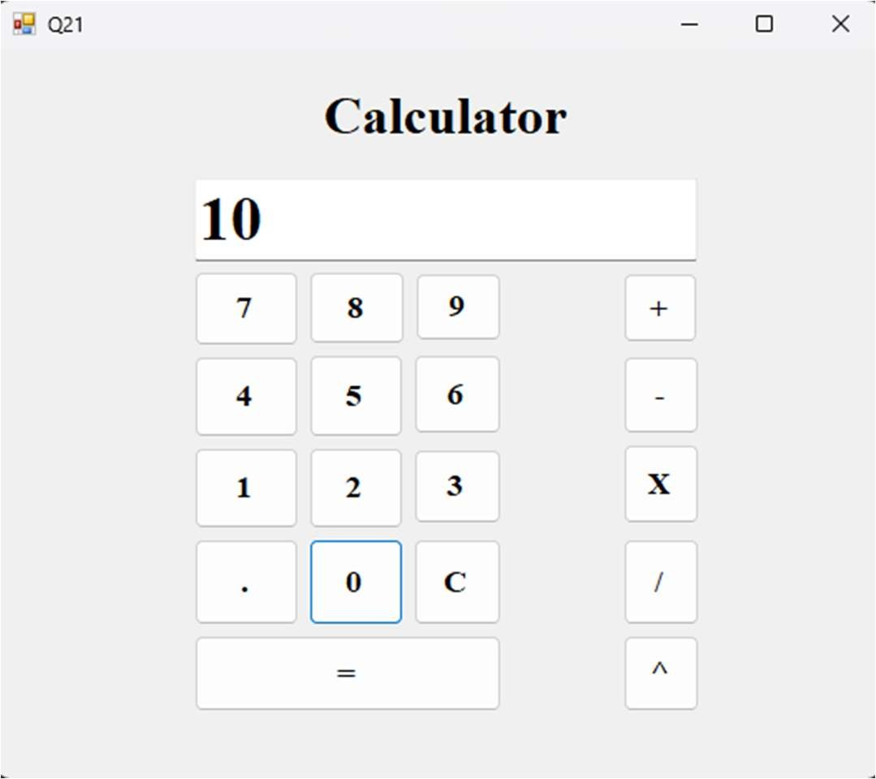

Q22 Write a program, using recursive function to generate Fibonacci Series.

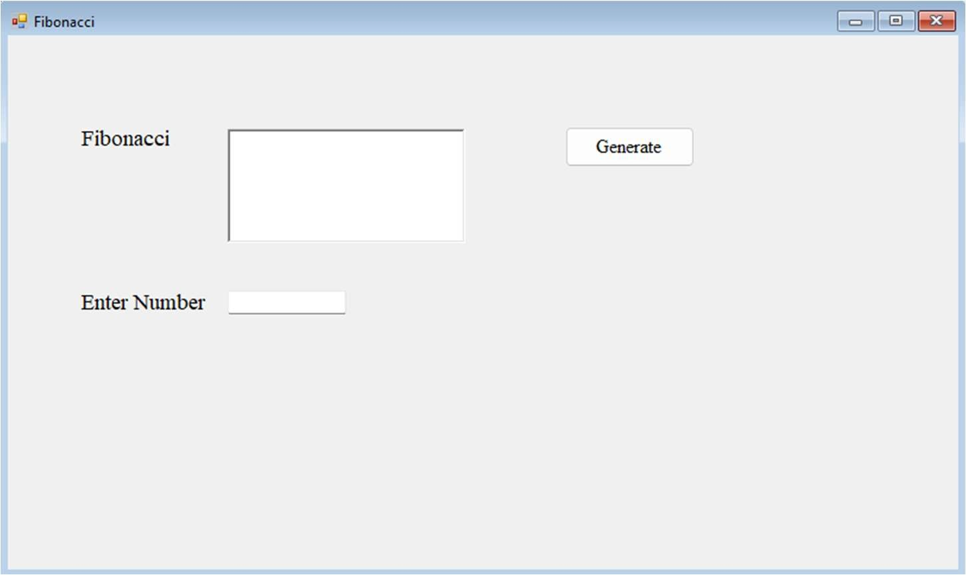

Public Class Q22

Function fib(ByVal n As Integer) As Integer If (n = 0 Or n = 1) Then

Return n Else

Return fib(n - 1) + fib(n - 2) End If

End Function

Private Sub Button1_Click(sender As Object, e As EventArgs) Handles Button1.Click Dim n As Integer = TextBox1.Text

While (n >= 0)

Dim s As String = fib(n) RichTextBox1.Text += s + " " n -= 1

End While End Sub

End Class

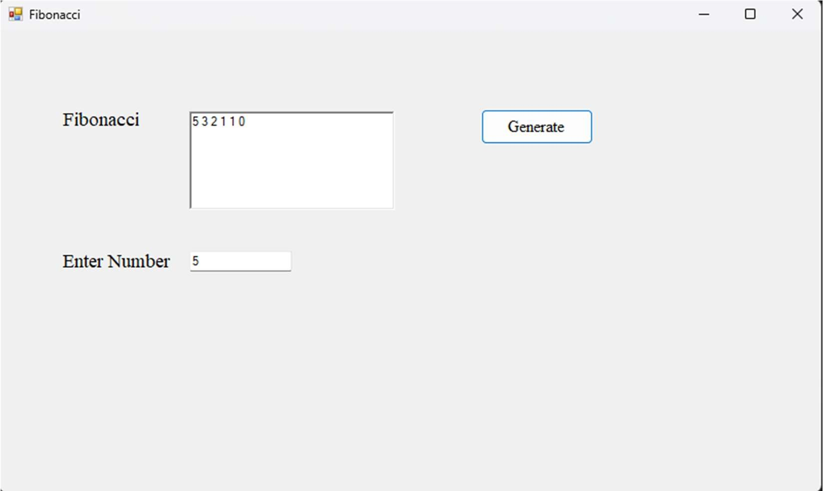

Q.23 Write a program to calculate pay that takes two parameters hours and wages and display the total pay of an employee.

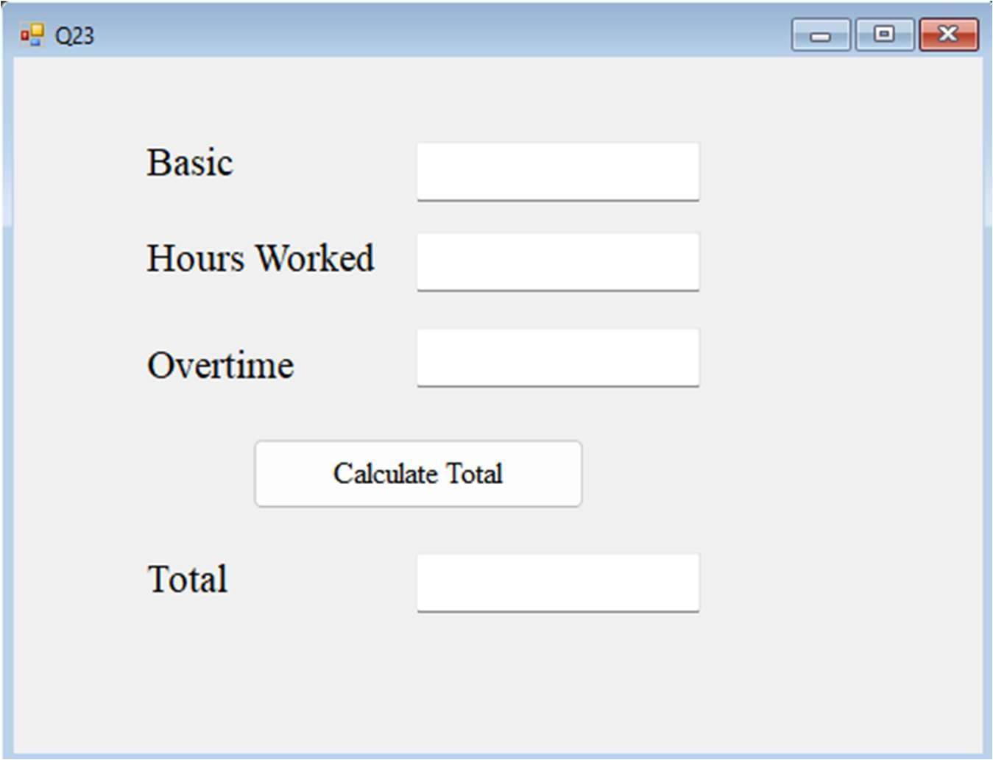

Public Class Q23

Dim hour, basic, overtime As Integer

Private Sub Button1_Click(sender As Object, e As EventArgs) Handles Button1.Click hour = Val(TextBox2.Text)

basic = Val(TextBox1.Text) overtime = Val(TextBox3.Text)

TextBox4.Text = basic + hour * overtime End Sub

End Class

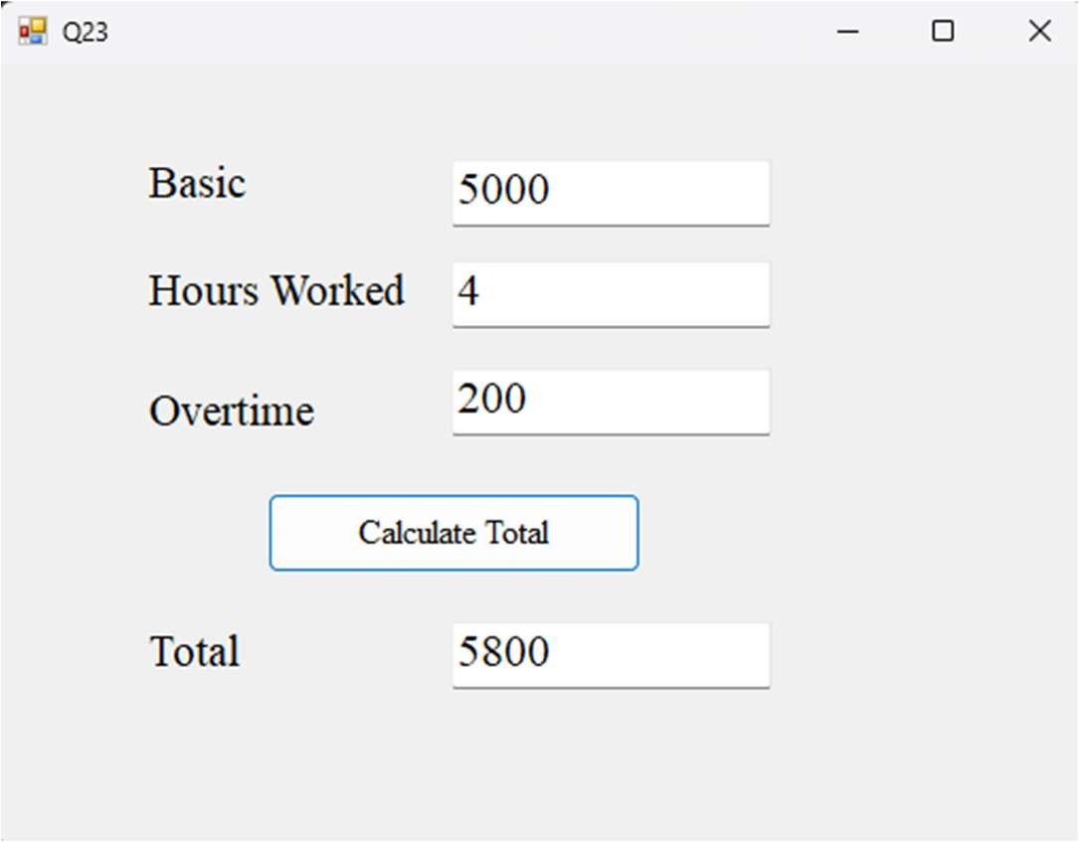

Q24 Write a program to print first n square less than 50 and print the sum of the all the square of the n number

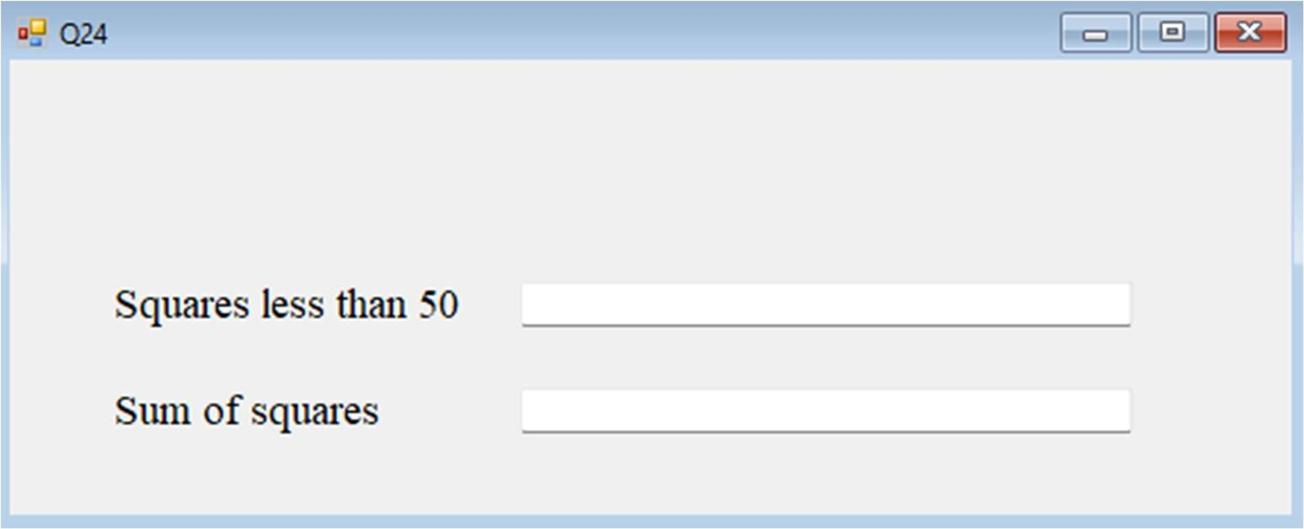

Public Class Q24

Private Sub Q24_Load(sender As Object, e As EventArgs) Handles MyBase.Load Dim n As Integer = 1

Dim sum As Integer = 0 Dim x As String

While n * n < 50 x = n * n

sum += n * n n += 1

TextBox1.Text += x + "" End While

TextBox2.Text = sum End Sub

End Class

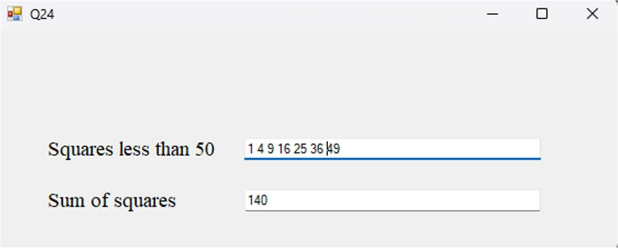

Q25 Create a project for book sales. Make text boxes for quantity, title and price with labels. Calculate total price, discount (15%) and discounted price.

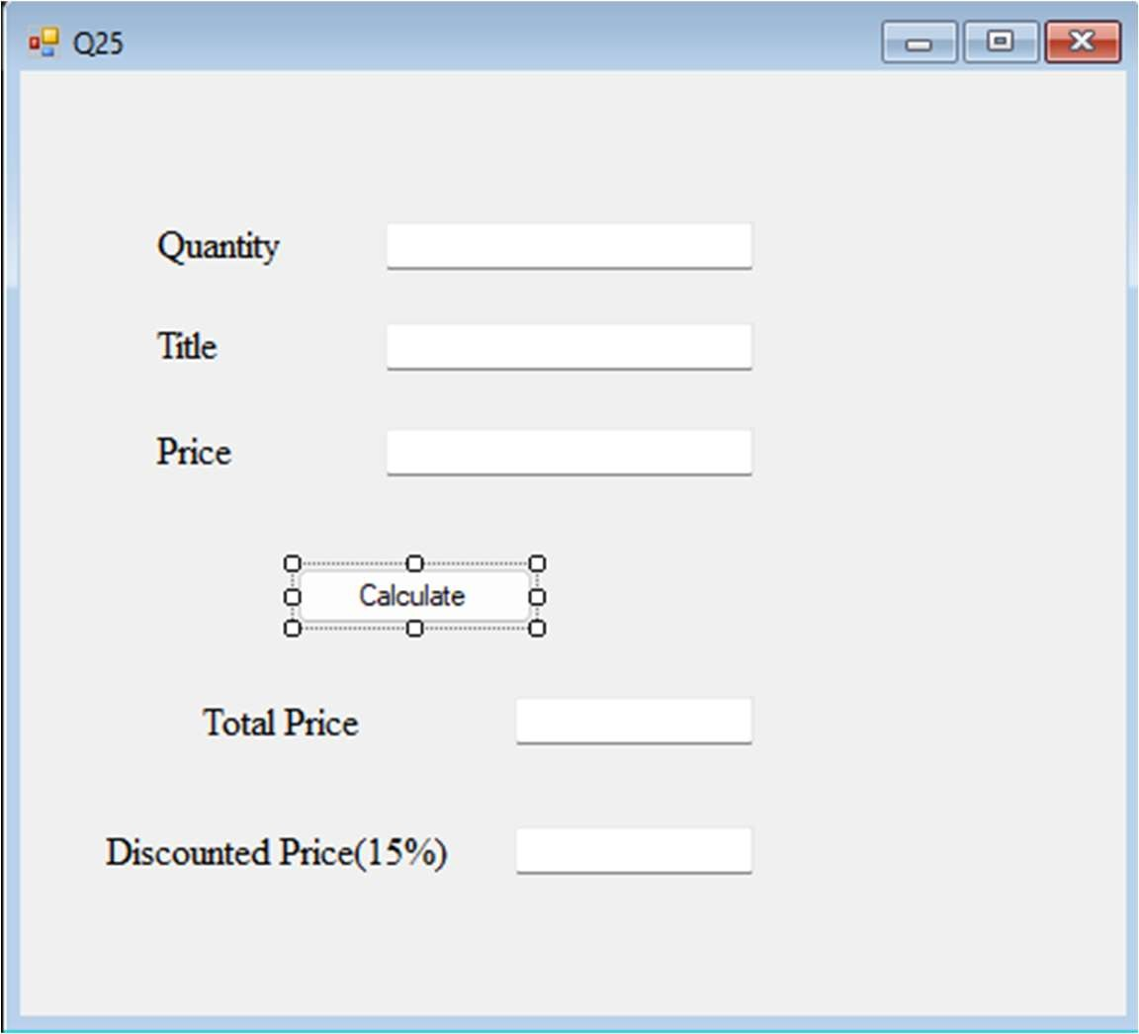

Public Class Q25

Private Sub Button1_Click(sender As Object, e As EventArgs) Handles Button1.Click Dim price As Integer = Val(TextBox1.Text) * Val(TextBox3.Text)

TextBox4.Text = price TextBox5.Text = price - (0.15 * price)

End Sub End Class

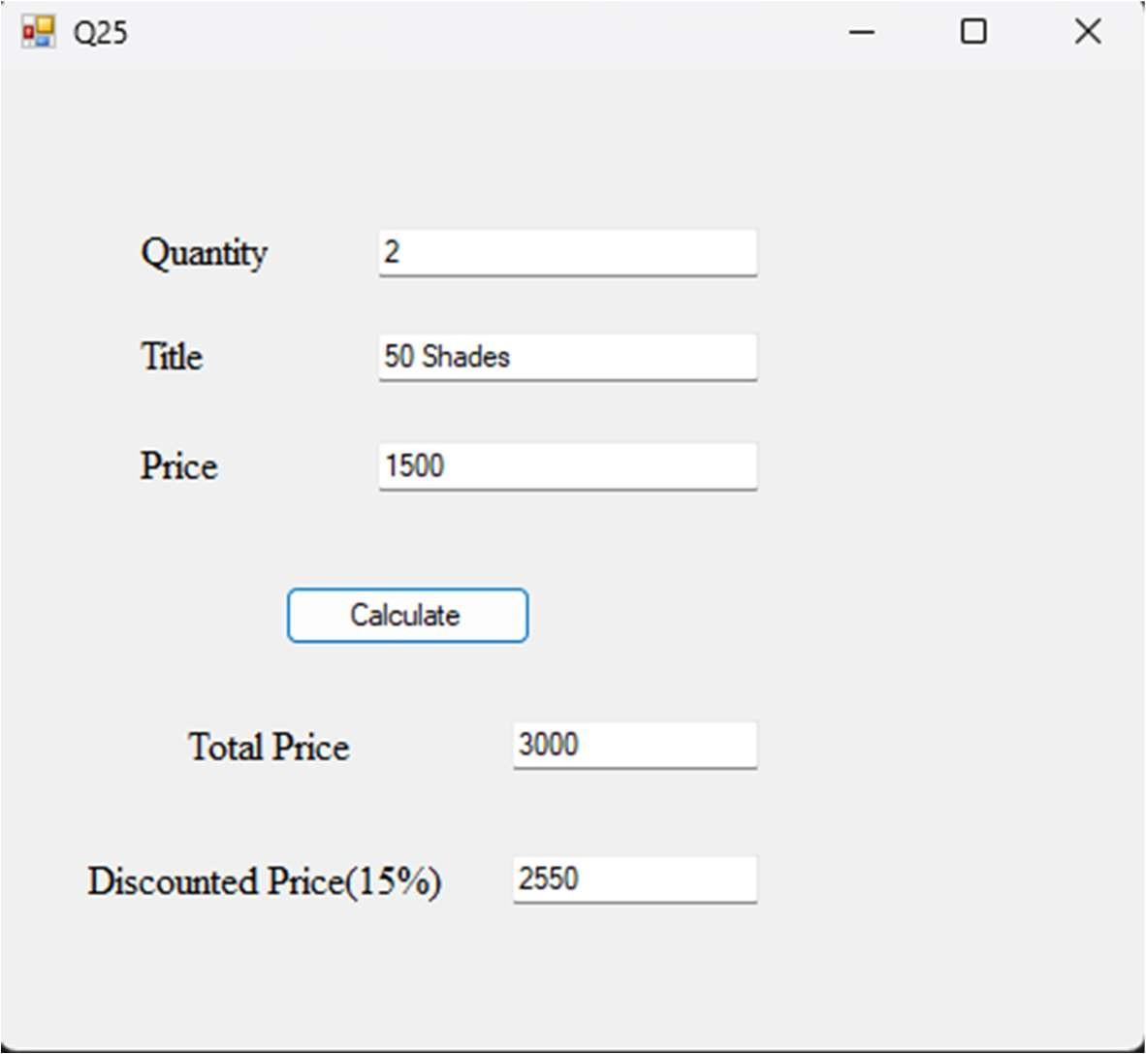

Q26 Create a text editor application. It should perform operation like cut, copy, paste and change in font, color of the selected text. Also implement new open and save-file menu option. Write a program to implement the concept of function overloading.

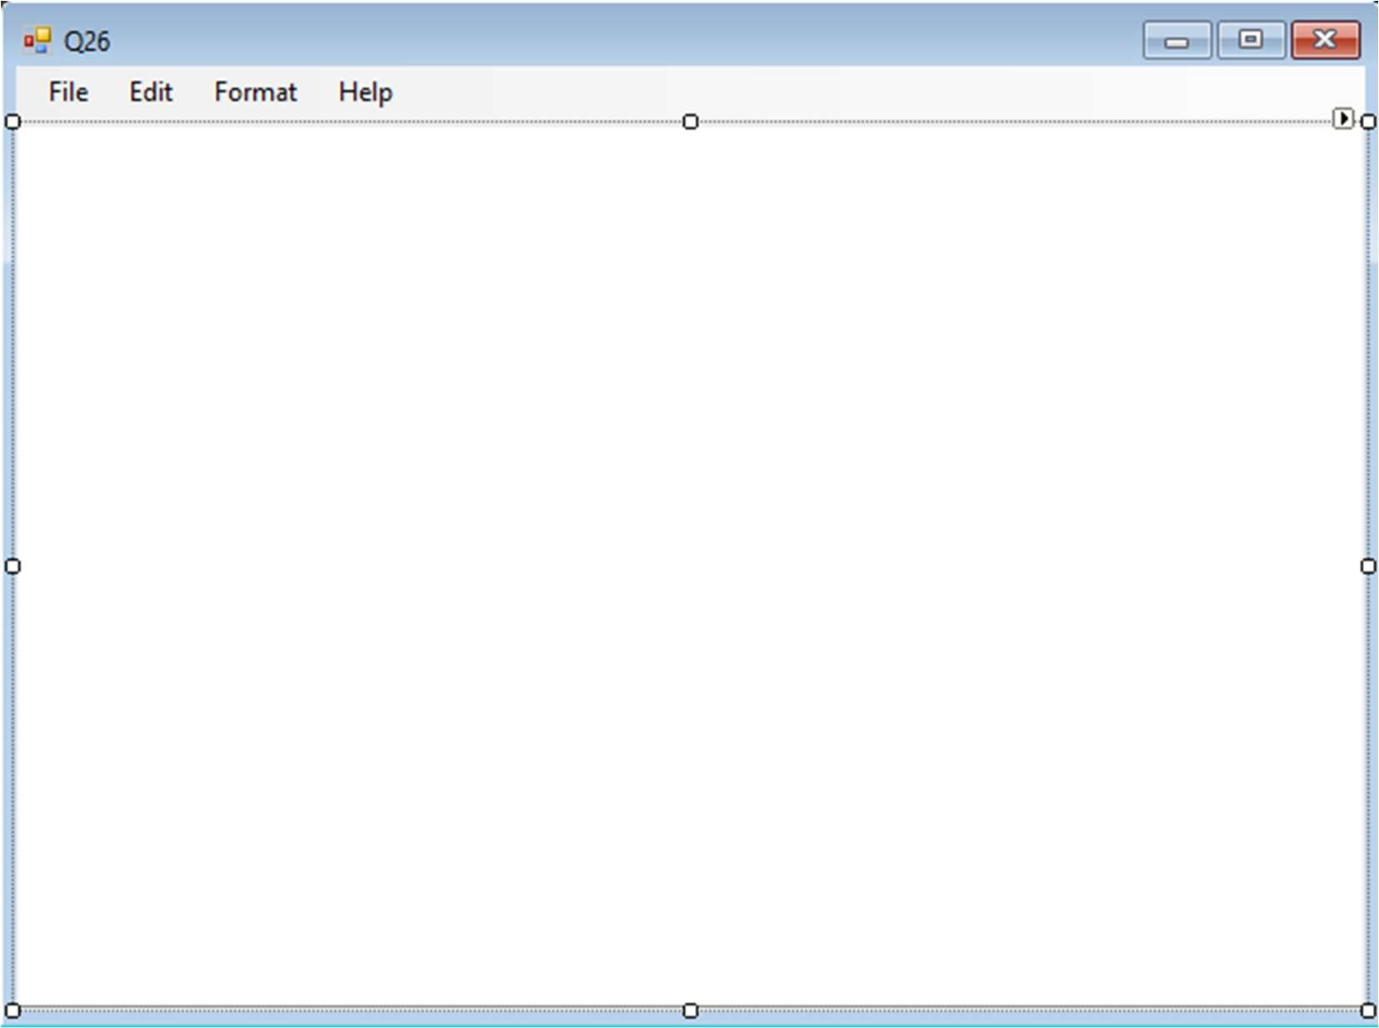

Public Class Q26

Private Sub NewToolStripMenuItem_Click(sender As Object, e As EventArgs) Handles NewToolStripMenuItem.Click

MsgBox("Do you want to save changes...", MsgBoxStyle.YesNoCancel) TextBox1.Text = " "

End Sub

Private Sub OpenToolStripMenuItem_Click(sender As Object, e As EventArgs) Handles OpenToolStripMenuItem.Click

If OpenFileDialog1.ShowDialog = Windows.Forms.DialogResult.OK Then

TextBox1.Text = My.Computer.FileSystem.ReadAllText(OpenFileDialog1.FileName)

End If End Sub

Private Sub SaveToolStripMenuItem_Click(sender As Object, e As EventArgs) Handles SaveToolStripMenuItem.Click

If SaveFileDialog1.ShowDialog = Windows.Forms.DialogResult.OK Then

My.Computer.FileSystem.WriteAllText(SaveFileDialog1.FileName, TextBox1.Text,

False)

End If End Sub

Private Sub PrintToolStripMenuItem_Click(sender As Object, e As EventArgs) Handles PrintToolStripMenuItem.Click

PrintDialog1.ShowDialog() End Sub

Private Sub ExitToolStripMenuItem_Click(sender As Object, e As EventArgs) Handles ExitToolStripMenuItem.Click

Me.Close() End Sub

Private Sub UndoToolStripMenuItem_Click(sender As Object, e As EventArgs) Handles UndoToolStripMenuItem.Click

TextBox1.Undo() End Sub

Private Sub CopyToolStripMenuItem_Click(sender As Object, e As EventArgs) Handles CopyToolStripMenuItem.Click

TextBox1.Copy() End Sub

Private Sub CutToolStripMenuItem_Click(sender As Object, e As EventArgs) Handles CutToolStripMenuItem.Click

TextBox1.Cut() End Sub

Private Sub PasteToolStripMenuItem_Click(sender As Object, e As EventArgs) Handles PasteToolStripMenuItem.Click

TextBox1.Paste() End Sub

Private Sub SelectAllToolStripMenuItem_Click(sender As Object, e As EventArgs) Handles SelectAllToolStripMenuItem.Click

TextBox1.SelectAll() End Sub

Private Sub FontToolStripMenuItem_Click(sender As Object, e As EventArgs) Handles FontToolStripMenuItem.Click

If FontDialog1.ShowDialog = Windows.Forms.DialogResult.OK Then TextBox1.Font = FontDialog1.Font

End If End Sub

Private Sub ColorToolStripMenuItem_Click(sender As Object, e As EventArgs) Handles ColorToolStripMenuItem.Click

If ColorDialog1.ShowDialog = Windows.Forms.DialogResult.OK Then TextBox1.ForeColor = ColorDialog1.Color

End If End Sub

Private Sub AboutToolStripMenuItem_Click(sender As Object, e As EventArgs) Handles AboutToolStripMenuItem.Click

MsgBox("Notepad developed by" & vbCrLf & "Tejas R Shinde") End Sub

End Class

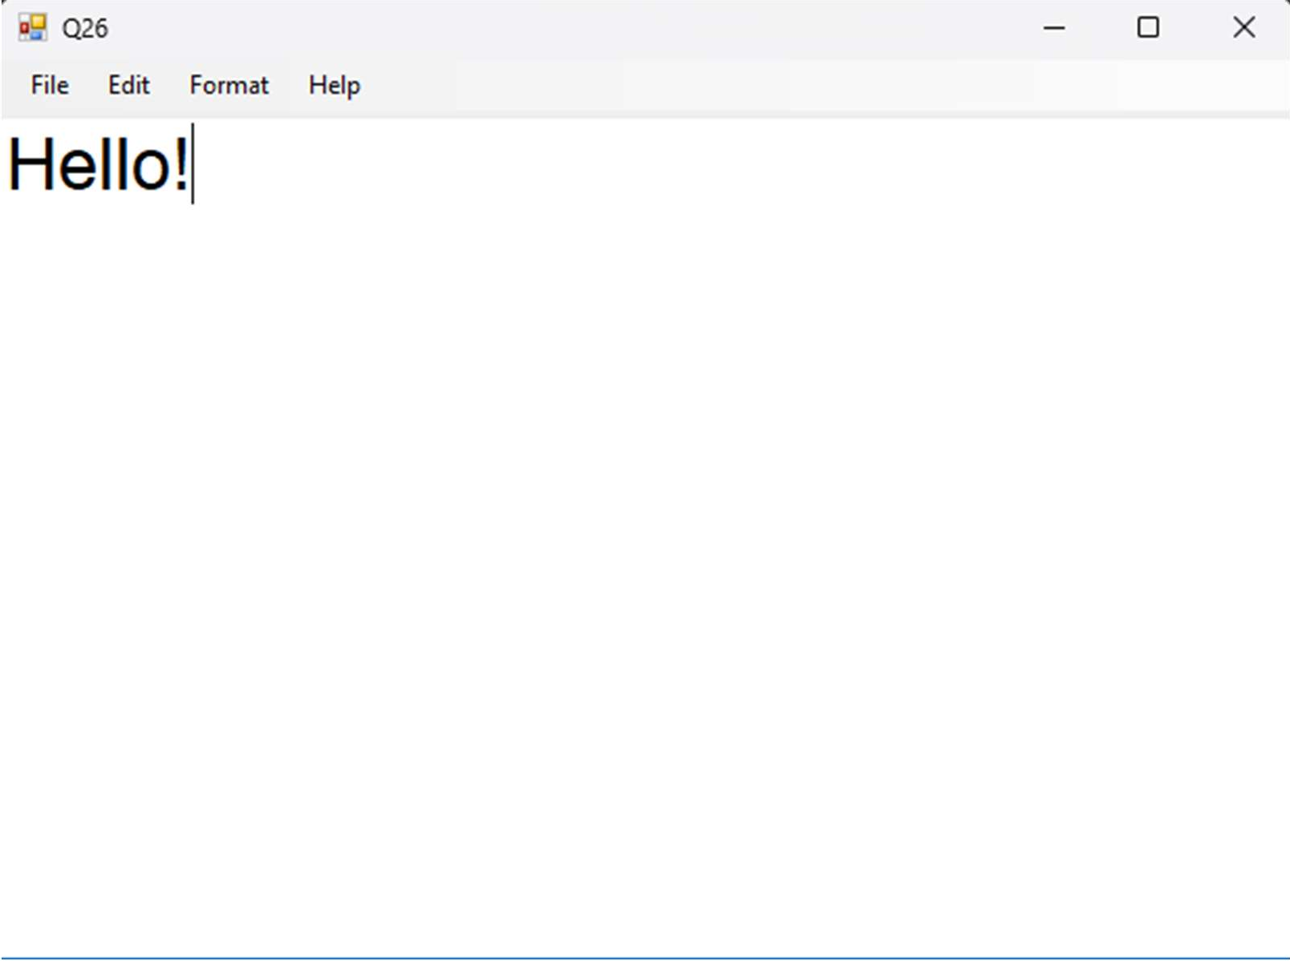

Q27 Using exception handling write a program to divide two numbers

Module Module1

Sub Division(ByVal num1 As Integer, ByVal num2 As Integer) Dim result As Integer

Try

result = num1 \ num2

Catch e As DivideByZeroException Console.WriteLine("Exception caught:{0}", e)

Finally

Console.WriteLine("Result: {0}", result) End Try

End Sub Sub Main()

Division(25, 0) Console.ReadKey()

End Sub End Module

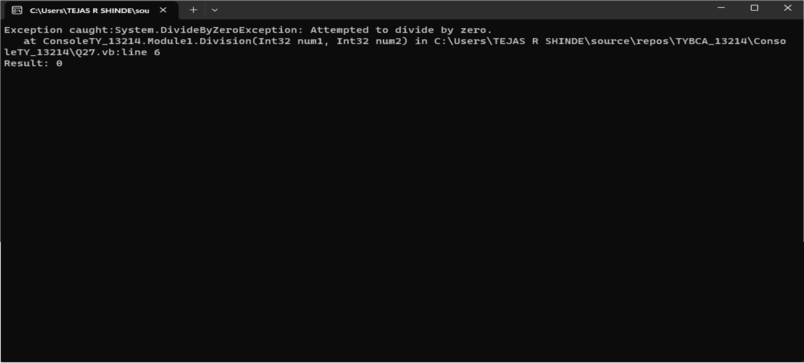

Q28 Currency Conversion

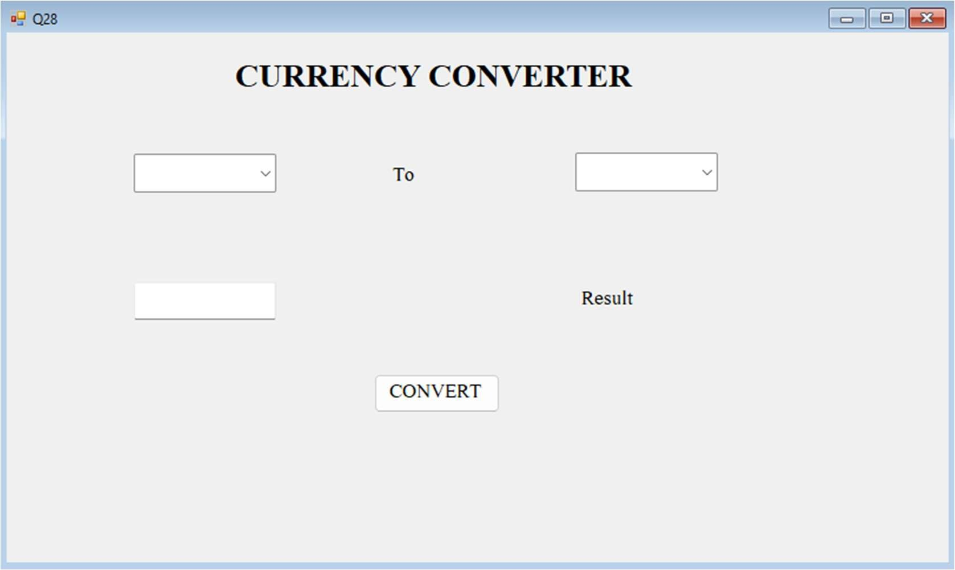

Public Class Q28

Dim x, y, z As Double

Private Sub Button1_Click(sender As Object, e As EventArgs) Handles Button1.Click If ComboBox1.Text = "POUND" And ComboBox2.Text = "USD" Then

x = TextBox1.Text y = x * 90

z = y / 70 Label2.Text = z

ElseIf ComboBox1.Text = "POUND" And ComboBox2.Text = "INR" Then Label2.Text = Nothing

x = TextBox1.Text y = x * 90 Label2.Text = y

ElseIf ComboBox1.Text = "USD" And ComboBox2.Text = "INR" Then Label2.Text = Nothing

x = TextBox1.Text

y = x * 70 Label2.Text = y

ElseIf ComboBox1.Text = "USD" And ComboBox2.Text = "GBP" Then Label2.Text = Nothing

x = TextBox1.Text y = x * 70

z = y / 90 Label2.Text = z

ElseIf ComboBox1.Text = "INR" And ComboBox2.Text = "USD" Then Label2.Text = Nothing

x = TextBox1.Text y = x / 70 Label2.Text = y

ElseIf ComboBox1.Text = "INR" And ComboBox2.Text = "GBP" Then Label2.Text = Nothing

x = TextBox1.Text y = x / 90 Label2.Text = y

Else

Label2.Text = Nothing x = TextBox1.Text Label2.Text = x

End If End Sub

End Class

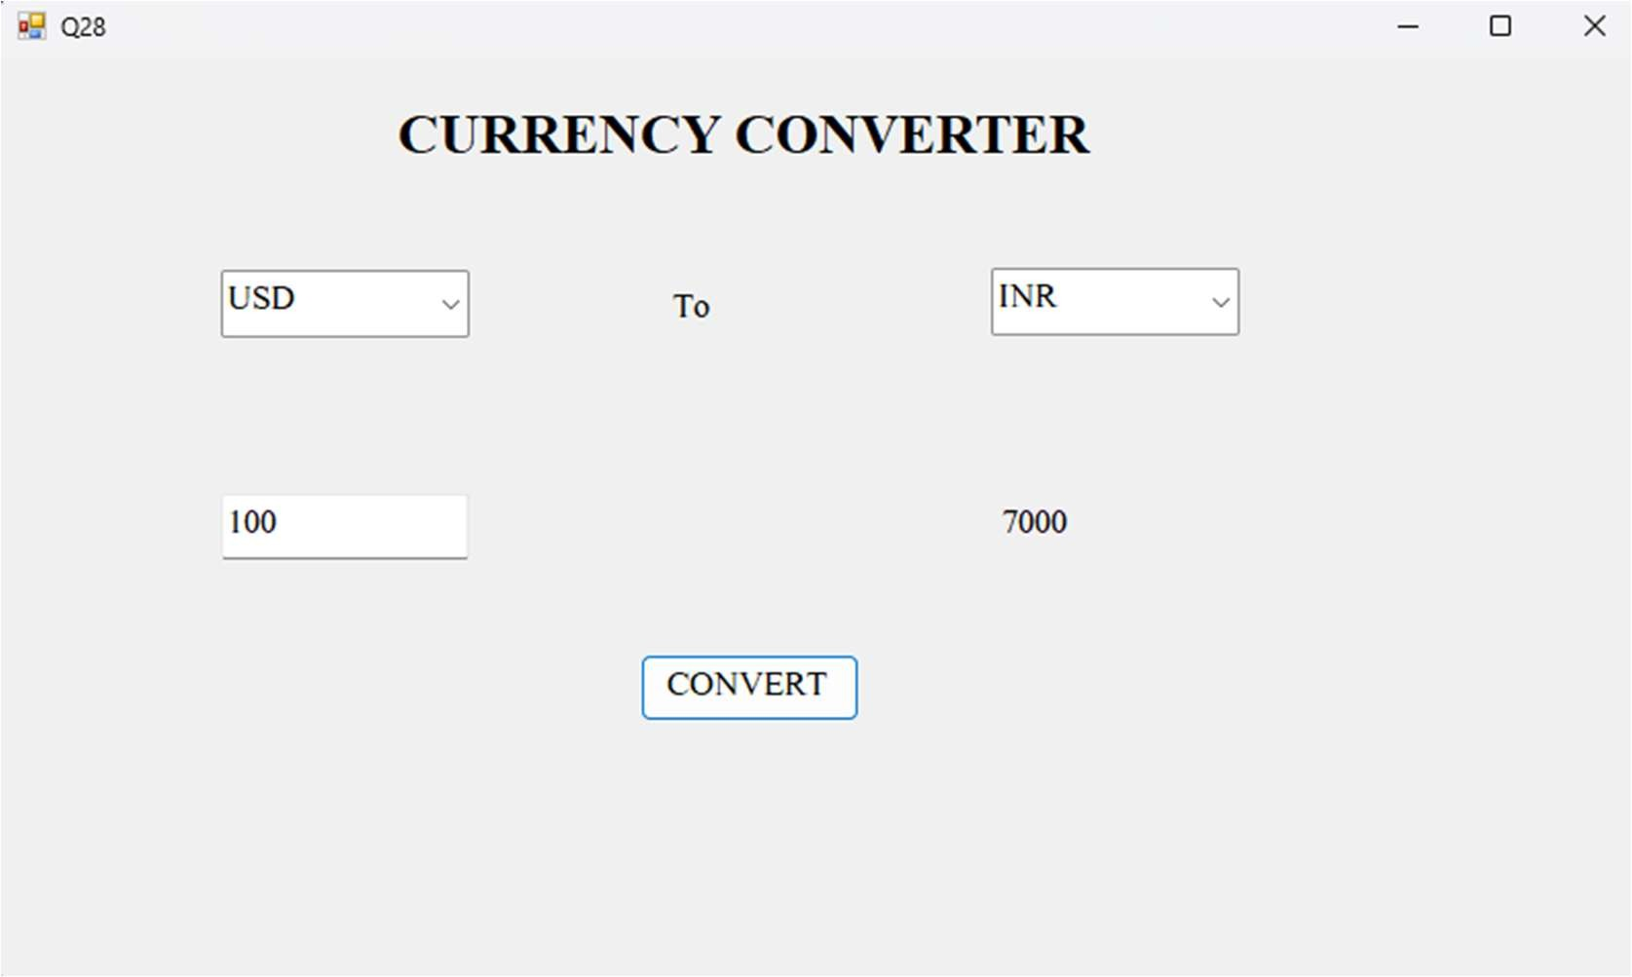

Q29. Write a VB.NET program to create a table Patient (Pid, PName, Contact_No, Disease). Insert records into table and display appropriate message in message box. (Use MS Access to create db)

Q30. Write a VB.NET program to create a table Employee (Eid, EName, Designation, doj). Insert records into table and display it in GridView. (Use SQLServer to create db)

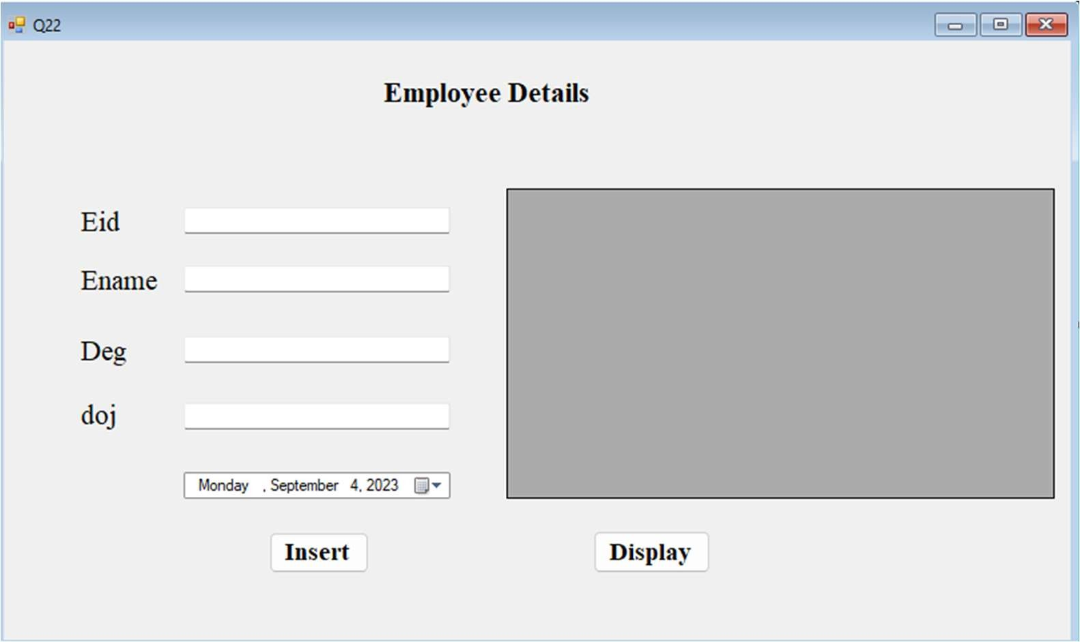

Imports System.Data.SqlClient Public Class Q30

Private connection As SqlConnection Private command As SqlCommand Private adapter As SqlDataAdapter Private str As String

Private ds As New DataSet

Private Sub Button1_Click(sender As Object, e As EventArgs) Handles Button1.Click connection = New SqlConnection("Data

Source=(LocalDB)\MSSQLLocalDB;AttachDbFilename=C:\Users\TEJAS R SHINDE\source\repos\TYBCA_13214\TYBCA_13214\Employee.mdf;Integrated Security=True")

connection.Open()

str = New String("Insert into Employee values(" & CInt(TextBox1.Text) & ",'" & TextBox2.Text & "','" & TextBox3.Text & "','" & TextBox4.Text & "')")

command = New SqlCommand(str, connection) command.ExecuteNonQuery()

MsgBox("Record inserted") connection.Close()

End Sub

Private Sub Button2_Click(sender As Object, e As EventArgs) Handles Button2.Click connection = New SqlConnection("Data

Source=(LocalDB)\MSSQLLocalDB;AttachDbFilename=C:\Users\TEJAS R SHINDE\source\repos\TYBCA_13214\TYBCA_13214\Employee.mdf;Integrated Security=True")

connection.Open()

str = "select * from Employee"

adapter = New SqlDataAdapter(str, connection) adapter.Fill(ds, "Employee") DataGridView1.DataSource = ds DataGridView1.DataMember = "Employee" connection.Close()

End Sub End Class

Q31. Write a VB.NET program to create a table student (RollNo ,SName, Class). Insert the records (Max: 5). Update class of students to ‘TYBCA’ whose class is ‘SYBCA’ and display updated records in GridView. (Use MS Access to create db)

Q32. Write a VB.NET program to create teacher table (Tid , TName, subject). Insert the records (Max : 5). Search record of a teacher who teaches “VB.NET” subject and display result in GridView. (Use SQL to create db).

Q33. Write a VB.NET program to create movie table (Mv_Name, Release_year, Director). Insert the records(Max: 5). Delete the records of movies whose release year is 2015 and display appropriate message in messagebox.(Use MS Access to create db)

Q34. Write a VB.NET program to accept the details of customer (CName, Contact_No, Email_id). Store it into the database with proper validation and display appropriate message by using Messagebox.(Use MS Access )

Q35. Write a VB.NET program to accept the details of product (pid, pname, expiry_date, price). Store it into the database and display it on the Crystal Report.(Use SQL Server)

Q36. Write a VB.NET program to accept the details Supplier (SupId, SupName, Phone_No, Address ) store it into the database and display it. (Use Crystal Report)

Q37. Write a VB.NET program to create Author table (aid , aname , book_name). Insert the records (Max 5). Delete a record of author who has written “VB.NET book” and display remaining records on the Crystal Report. (Use MS Access to create db)

Q38. Write a VB.NET program to create player table (Pid,PName,Game, no_of_matches). Insert records and update number of matches of ‘Sachin Tendulkar’ and display result in Crystal Report. (Use SQL to create db)